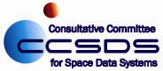

CCSDS Management Council (via CCSDS Secretariat Office)

American Institute of Aeronautics and Astronautics (C/O Nick Tongson)

1801 Alexander Bell Dr, Ste 500

Reston, VA 20191-4344 May 17, 2011

Mr. Fred Farina

Office of Technology Transfer

California Institute of Technology

1200 E. California Blvd M/C 210-85

Pasadena, CA 91125

##### Subject: CalTech Patented Technologies in CCSDS Standards

##### Dear Mr. Farina,

The Consultative Committee for Space Data Systems (CCSDS) is an international organization that develops standards for spaceflight interoperability between the spacefaring nations of the world. In the process of establishing some important standards for space communications, CCSDS teams have attempted to capitalize on the benefits of certain patented technologies However, the teams have encountered licensing obstacles that are preventing them from standardizing these technologies, effectively blocking important international capabilities for spaceflight missions.

In my capacity as Chairman of the CCSDS Management Council (CMC), I am writing to request your assistance. The technology which CCSDS wants to reference in an international standard is Serially Concatenated Convolutional Coding (SCCC), which is the subject of US Patent No. 6023783 (Hybrid Concatenated Codes and Iterative Decoding). We understand that the patent was assigned to CalTech and that CalTech subsequently assigned exclusive licensing rights to Intellectual Ventures (IV©), LLC.

Before international standardization can occur, the policies of CCSDS and the International Standards Organization (ISO -- with which CCSDS is affiliated) require the licensor to sign an ISO Declaration form (attached) that assures the community that licenses for the technology will be made available on a “Reasonable And Non-Discriminatory” (RAND) basis. It is not required to quantify exact license terms, although the working level teams have a goal of also securing that information to help verify that the license terms are RAND. The patent-holder can also indicate on the ISO Declaration form that their licensing terms are not RAND, but of course in that situation, we cannot proceed with standardization. Failure to declare RAND licensing terms would be a very unfortunate outcome, because some CCSDS space agencies have invested considerably in the effort to standardize SCCC technology within CCSDS. It is therefore critical that we find a way through this, and that we secure the licensor’s signature on the ISO Declaration form.

Following prior guidance from CalTech, the European Space Agency (ESA) team has been in contact with IV© for almost 19 months, but throughout that period IV© has been largely evasive and unresponsive. Accordingly, ESA has given up their efforts to get IV© to agree to license the code and to sign the ISO Declaration form. As a senior Member of the CCSDS, ESA has now elevated the issue to CCSDS management, and that is the reason for this letter. We sincerely hope that CalTech can help us to find a way through these issues and to secure the necessary signatures on the ISO Declaration form.

Your assistance in this matter is greatly appreciated.

Sincerely,

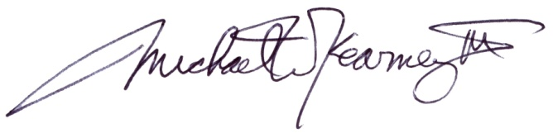

Michael W. Kearney, III

CCSDS Management Council Chairman and General Secretary

[Mike.Kearney@nasa.gov](mailto:Mike.Kearney@nasa.gov)

NASA Marshall Space Flight Center - Huntsville, AL 35812