
Draft Recommendation for
Space Data System Standards
Mission OPerations File MANAGEMENT Services
Draft Recommended Standard
CCSDS 000.0-W-0
White Book
September 2018

AUTHORITY

 | Issue: | White Book, Issue 0
 | Date: | September 2018
 | Location: | Not Applicable
(WHEN THIS RECOMMENDED STANDARD IS FINALIZED, IT WILL CONTAIN THE FOLLOWING STATEMENT OF AUTHORITY:)
This document has been approved for publication by the Management Council of the Consultative Committee for Space Data Systems (CCSDS) and represents the consensus technical agreement of the participating CCSDS Member Agencies. The procedure for review and authorization of CCSDS documents is detailed in Organization and Processes for the Consultative Committee for Space Data Systems (CCSDS A02.1-Y-4), and the record of Agency participation in the authorization of this document can be obtained from the CCSDS Secretariat at the address below.

This document is published and maintained by:

CCSDS Secretariat
Space Communications and Navigation Office, 7L70
Space Operations Mission Directorate
NASA Headquarters
Washington, DC 20546-0001, USA

FOREWORD
[Foreword text specific to this document goes here. The text below is boilerplate.]
Attention is drawn to the possibility that some of the elements of this document may be the subject of patent rights. CCSDS shall not be held responsible for identifying any or all such patent rights.
Through the process of normal evolution, it is expected that expansion, deletion, or modification of this document may occur. This Recommended Standard is therefore subject to CCSDS document management and change control procedures, which are defined in Organization and Processes for the Consultative Committee for Space Data Systems (CCSDS A02.1-Y-4). Current versions of CCSDS documents are maintained at the CCSDS Web site:
http://www.ccsds.org/
Questions relating to the contents or status of this document should be addressed to the CCSDS Secretariat at the address indicated on page i.
At time of publication, the active Member and Observer Agencies of the CCSDS were:
Member Agencies
- Agenzia Spaziale Italiana (ASI)/Italy.
- Canadian Space Agency (CSA)/Canada.
- Centre National d’Etudes Spatiales (CNES)/France.
- China National Space Administration (CNSA)/People’s Republic of China.
- Deutsches Zentrum für Luft- und Raumfahrt (DLR)/Germany.
- European Space Agency (ESA)/Europe.
- Federal Space Agency (FSA)/Russian Federation.
- Instituto Nacional de Pesquisas Espaciais (INPE)/Brazil.
- Japan Aerospace Exploration Agency (JAXA)/Japan.
- National Aeronautics and Space Administration (NASA)/USA.
- UK Space Agency/United Kingdom.
Observer Agencies
- Austrian Space Agency (ASA)/Austria.
- Belgian Federal Science Policy Office (BFSPO)/Belgium.
- Central Research Institute of Machine Building (TsNIIMash)/Russian Federation.
- China Satellite Launch and Tracking Control General, Beijing Institute of Tracking and Telecommunications Technology (CLTC/BITTT)/China.
- Chinese Academy of Sciences (CAS)/China.
- Chinese Academy of Space Technology (CAST)/China.
- Commonwealth Scientific and Industrial Research Organization (CSIRO)/Australia.
- Danish National Space Center (DNSC)/Denmark.
- Departamento de Ciência e Tecnologia Aeroespacial (DCTA)/Brazil.
- European Organization for the Exploitation of Meteorological Satellites (EUMETSAT)/Europe.
- European Telecommunications Satellite Organization (EUTELSAT)/Europe.
- Geo-Informatics and Space Technology Development Agency (GISTDA)/Thailand.
- Hellenic National Space Committee (HNSC)/Greece.
- Indian Space Research Organization (ISRO)/India.
- Institute of Space Research (IKI)/Russian Federation.
- KFKI Research Institute for Particle & Nuclear Physics (KFKI)/Hungary.
- Korea Aerospace Research Institute (KARI)/Korea.
- Ministry of Communications (MOC)/Israel.
- National Institute of Information and Communications Technology (NICT)/Japan.
- National Oceanic and Atmospheric Administration (NOAA)/USA.
- National Space Agency of the Republic of Kazakhstan (NSARK)/Kazakhstan.
- National Space Organization (NSPO)/Chinese Taipei.
- Naval Center for Space Technology (NCST)/USA.
- Scientific and Technological Research Council of Turkey (TUBITAK)/Turkey.
- South African National Space Agency (SANSA)/Republic of South Africa.
- Space and Upper Atmosphere Research Commission (SUPARCO)/Pakistan.
- Swedish Space Corporation (SSC)/Sweden.
- Swiss Space Office (SSO)/Switzerland.
- United States Geological Survey (USGS)/USA.
PREFACE
This document is a draft CCSDS Recommended Standard. Its ‘White Book’ status indicates that its contents are not stable, and several iterations resulting in substantial technical changes are likely to occur before it is considered to be sufficiently mature to be released for review by the CCSDS Agencies.
Implementers are cautioned not to fabricate any final equipment in accordance with this document’s technical content.
Recipients of this draft are invited to submit, with their comments, notification of any relevant patent rights of which they are aware and to provide supporting documentation.

DOCUMENT CONTROL

Document | Title and Issue | Date | Status
CCSDS 000.0-W-0 | Mission Operations File Services, Proposed Draft Recommended Standard, Issue 0 | September 2018 | Current draft

CONTENTS
Section Page
1 Introduction 1-1
1.1 General 1-1
1.2 Purpose and Scope 1-1
1.3 Applicability 1-2
1.4 Rationale 1-2
1.5 Document structure 1-2
1.6 Definitions and Conventions 1-2
1.7 NOMENCLATURE 1-4
1.8 Conventions 1-5
1.9 References 1-6
2 Overview 2-1
2.1 General 2-1
2.2 File System Service 2-2
2.3 File Transfer Service 2-2
3 Service Specifications 3-7
3.1 General 3-7
3.2 Service: File System 3-7
3.3 Service: File Transfer 3-22
4 Data Types 4-33
4.1 Service Data Types: FILE SYSTEM 4-33
4.2 Service Data Types: FILE TRANSFER 4-35
5 Error Codes 5-38
5.1 General 5-38
5.2 File System 5-40
5.3 File Transfer 5-42
6 XML Service Specifications 6-1

ANNEX A Implementation Conformance Statement (ICS) Proforma (normative) A-1
ANNEX B Security, SANA, and Patent Considerations (Informative) B-1
ANNEX C Acronyms (Informative) C-3
ANNEX D Informative References (Informative) D-4
ANNEX E OPEN ISSUES E-5
Figure
Figure 2-1: Mission Operations Services concept document set 2-1
Figure 2-2: Scenario 1 - basic point-to-point 2-3
Figure 2-3: Scenario 2 - full-scale point-to-point 2-3
Figure 2-4: Scenario 3 - full-scale point-to-point for typical ground-space setup, with the Mission Operations Centre on the left and the spacecraft on the right. 2-4
Figure 2-5: Scenario 4 - basic point-to-point setup with CFDP store-and-forward 2-5
Figure 2-6: Scenario 5 - basic setup with Mission Operations action forwarding and CFDP store-and-forward 2-6
Figure 2-7: Scenario 6 – basic point-to-point setup but for the case when the consumer is not the CFDP source or the destination of the file. 2-6

Table
Table 1-1: Example Operation Template 1-5
Table 3-1: File System Service Operations 3-7
Table 3-2: File Transfer Service Operations 3-22
Table 5-1: Overview of the File System Service Error Codes 5-38
Table 5-2: Overview of the File System Service Error Codes 5-40
Table 5-3: Overview of the File Transfer Service Error Codes 5-42

Introduction

General
This Recommended Standard defines the Mission Operations (MO) File Management (FM) Services, extending the initial set of services proposed in [D4], Mission Operations Services Concept.
The File Management (FM) Services bring File Based Operations (FBO) to the Mission Operations stack. These services allow a mission to manage remote files and file systems, and transfer files over a space link. These functionalities are split into two separate services:
- The File System Service, that provides the capabilities to create and manage files in remote file systems.
- The File Transfer Service, that provides the capabilities to monitor and control file transfers across the space link. This service assumes the use of the CCSDS File Delivery Protocol (CFDP) [D5] as the underlying file delivery mechanism (TBC - see issue 1 in ANNEX E).
These services are defined in terms of the Common Object Model (COM) (see reference [3], Mission Operations Common Object Model), and the Message Abstraction Layer (MAL) (see reference [2], Mission Operations Message Abstraction Layer).

Purpose and Scope
This Recommended Standard defines, in an abstract manner, the File System Service and the File Transfer Service in terms of:
- the operations necessary to provide the services;
- the parameter data associated with each operation;
- the required behaviour of each operation;
- the use of the COM.
It does not specify:
- individual implementations or products;
- the implementation of entities or interfaces within real systems;
the methods or technologies required for communications.

Applicability
This specification is applicable to any mission that needs to manage and transfer files over space links.

Rationale
The primary goal of CCSDS is to increase the level of interoperability among agencies. This Recommended Practice furthers that goal by providing a standard service specification for the basic monitor and control of a remote entity. This supports multi-agency missions by providing a single specification for the exchange of basic monitor and control information.

Document structure
This Recommended Standard is organised as follows:
- Section 1 provides purpose and scope, applicability, and rationale of this Recommended Practice and lists the definitions, conventions, and references used throughout the document;
- Section 2 presents an overview of the concepts;
- Section 3 presents the specifications for the File System and File Transfer Services;
- Section 4 is a formal specification of the data types used by the services;
- Section 5 lists the error codes;
- section 6 specifies the internet location of the formal service specification eXtensible Markup Language (XML).

Definitions and Conventions

Definitions
software component (component): A software unit supporting the business function. Components offer their function as services, which can either be used internally or which can be made available for use outside the component through provided service interfaces. Components may also depend on services provided by other components through consumed service interfaces.
hardware component: A complex physical entity (such as a spacecraft, a tracking system, or a control system) or an individual physical entity of a system (such as an instrument, a computer, or a piece of communications equipment). A hardware component may be composed from other hardware components. Each hardware component may host one or more software components. Each hardware component has one or more ports where connections to other hardware components are made. Any given port on the hardware component may expose one or more service interfaces.
service: A set of capabilities that a component provides to another component via an interface. A service is defined in terms of the set of operations that can be invoked and performed through the service interface. Service specifications define the capabilities, behaviour, and external interfaces, but do not define the implementation.
service interface: A set of interactions provided by a component for participation with another component for some purpose, along with constraints on how they can occur. A service interface is an external interface of a service where the behaviour of the service provider component is exposed. Each service will have one defined ‘provided service interface’ and may have one or more ‘consumed service interface’ and one ‘management service interface’.
provided service interface: A service interface that exposes the service function contained in a component for use by service consumers. It receives the MAL messages from a consumed service interface and maps them into Application Program Interface (API) calls on the provider component.
consumed service interface: The API presented to the consumer component that maps from the Service operations to one or more Service Data Units (SDUs) contained in MAL messages that are transported to the provided service interface.
management service interface: A service interface that exposes management functions of a service function contained in a component for use by service consumers.
service provider (provider): A component that offers a service to another by means of one of its provided service interfaces.
service consumer (consumer): A component that consumes or uses a service provided by another component. A component may be a provider of some services and a consumer of others.
service data unit, SDU: A unit of data that is sent by a service interface and is transmitted, semantically unchanged, to a peer service interface.
service extension: Addition of capabilities to a base service. A service may extend the capabilities of another service with additional operations. An extended service is indistinguishable from the base service to consumers such that consumers of the base service can also be consumers of the extended service without modification.
service capability set: A grouping of service operations. The specification of services is based on the expectation that different deployments require different levels of complexity and functionality from a service. To this end a given service may be implementable at one of several distinct levels, corresponding to the inclusion of one or more capability sets. The capability sets define a grouping of the service operations that remains sensible and coherent; it also provides a service provider with an ability to communicate to a consumer its capability.
filestore: A system used to store files [D5]. A filestore may be organized in one or multiple file systems.
file system: TBW
CFDP entity: A functioning instance of an implementation of the CFDP protocol, roughly analogous to an Internet protocol host. Each CFDP entity has access to exactly one filestore. Each entity also maintains a Management Information Base (MIB), which contains such information as default values for user communications requirements, e.g., for address mapping, and for communication timer settings [D5].
node: TBW
transfer: TBW
transaction: The end-to-end transmission of a single File Delivery Unit (FDU) between two CFDP entities. A single transaction normally entails the transmission and reception of multiple Protocol Data Units (PDU) [D5].
transmission window: TBW
reception window: TBW
priority: TBW

NOMENCLATURE

Normative Text
The following conventions apply for the normative specifications in this Recommended Standard:
- the words ‘shall’ and ‘must’ imply a binding and verifiable specification;
- the word ‘should’ implies an optional, but desirable, specification;
- the word ‘may’ implies an optional specification;
- the words ‘is’, ‘are’, and ‘will’ imply statements of fact.
NOTE – These conventions do not imply constraints on diction in text that is clearly informative in nature.

Informative Text
In the normative sections of this document, informative text is set off from the normative specifications either in notes or under one of the following subsection headings:
- Overview;
- Background;
- Rationale;
- Discussion.

Conventions

Figures
In figures illustrating this document, Unified Modelling Language (UML) modelling diagrams are used. Reference [1] provides further information regarding diagrams types and their meaning.

Tables
The table format information presented here is extracted from section 2 of reference [2]. It is repeated here to aid in understanding tables as they are presented in this document. A full description of the table formats presented in this document can be found in section 2 of reference [2] and in section 2 of reference [3].
Each interaction pattern definition contains a table that defines the template for operations that use that pattern.
Table 1-11: Example Operation Template
Operation Identifier | <<Operation name>>
Interaction Pattern | <<Interaction pattern name>>
Pattern Sequence | Message | Body Type
<<Message direction>> | <<Message name>> | <<Message type>>
… | … | …
The message direction denotes the direction of the message relative to the provider of the pattern and is either IN or OUT. So all messages directed towards the provider are IN messages, and all messages directed away from the provider are OUT messages.
Blue cells (dark grey when printed on a monochrome printer) contain table headings, light grey cells contain fields that are fixed for a pattern, and white cells contain values that must be provided by the operation or structure.

References
The following publications contain provisions which, through reference in this text, constitute provisions of this document. At the time of publication, the editions indicated were valid. All publications are subject to revision, and users of this document are encouraged to investigate the possibility of applying the most recent editions of the publications indicated below. The CCSDS Secretariat maintains a register of currently valid CCSDS publications.
[1] Mission Operations Reference Model. Issue 1. Recommendation for Space Data System Practices (Magenta Book), CCSDS 520.1-M-1. Washington, D.C.: CCSDS, July 2010.
[2] Mission Operations Message Abstraction Layer. Issue 2. Recommendation for Space Data System Standards (Blue Book), CCSDS 521.0-B-2. Washington, D.C.: CCSDS, March 2013.
[3] Mission Operations Common Object Model. Issue 1. Recommendation for Space Data System Standards (Blue Book), CCSDS 521.1-B-1. Washington, D.C.: CCSDS, February 2014.
NOTE – Informative references are listed in ANNEX D.

Overview

General
The File Management (FM) Services provide operations to manage remote files and file systems, and transfer files over space links, e.g., between an Earth-bound ground-station and an orbiting spacecraft, or between a spacecraft and a planetary rover. The functionalities are implemented as two separate services: the File System Service and the File Transfer Service.
The following diagram presents the set of standards documentation in support of the Mission Operations Services Concept. The File Management Services belong to the ‘Service Specifications’ documentation referenced in figure 2-1.
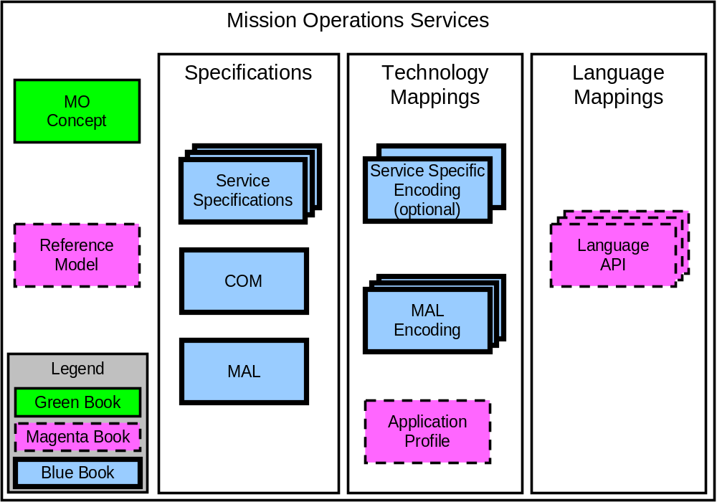
Figure 2-11: Mission Operations Services concept document set
NOTE – References D4 and [1] contain additional information about the MO Services Concept and the MO Reference Model, respectively.
The MO FM services build upon the layering concept outlined in reference [D4] and are defined in terms of the MO MAL outlined in reference [2], so it is possible to deploy them over any supported protocol and message transport. The FM services are also defined in terms of the COM, as defined in reference [3], and builds upon the COM activity tracking service, the COM event service and the COM archive.
NOTE – The services defined in this specification are not dependent on any of the other services (TBC - see issue 1 in ANNEX E), other than the COM services, and are complete in their own right. An implementation is free to opt out of any service and also any capability set of these services; however, it may not make sense to support certain services without others.

File System Service
TBW

File Transfer Service
There are five types of elements involved in a file transaction:
- Source CFDP Entity: this is the CFPD instance local to the file store where the file being transferred is originally located.
- Destination CFDP Entity: this is the CFDP instance local to the file store where the file being transferred shall ultimately be stored.
- Service Consumer: this is the consumer for the File Transfer service. It is the application that initiates and controls the transfer of the files over CFDP.
- Service Provider: this is the provider for the File Transfer service. It is the application that controls the Source CFDP Entity. Typically the Service Provider and the Source CFDP Entity are both deployed within the same application (mission control system, onboard software, other).
- Waypoints: these are (optional) intermediate CFDP entities that receive and send copies of the file being transferred. Waypoints are used when the Source and Destination have no direct connectivity.
to Figure 2-7 depict six scenarios where these five elements are deployed in different ways.
Scenario 1 depicts the most typical setup, where a consumer wants to transfer a file from a remote filestore to its local filestore. In this case the service consumer is co-located with the CFDP destination entity, and the service provider is co-located with the CFDP source destiny. In this particular setup, files can only be transferred in one direction.

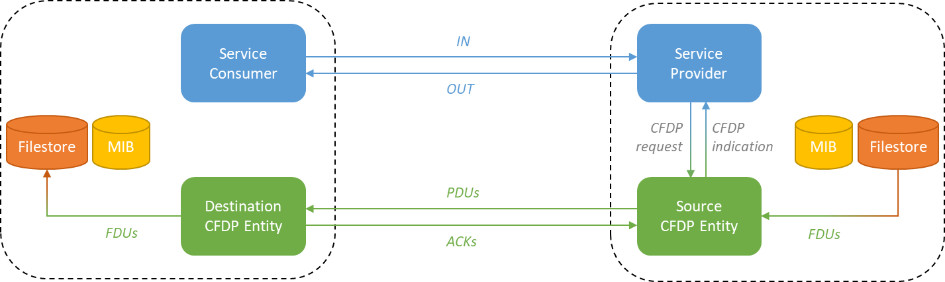

Figure 2-2: Scenario 1 - basic point-to-point

Scenario 2 extends the first scenario to consider all possible consumer-provider interfaces. In this scenario both systems can received and send files, and both consumers can initiate a file transfer from its local filestore to the remote filestore, and from the remote filestore to its local filestore.

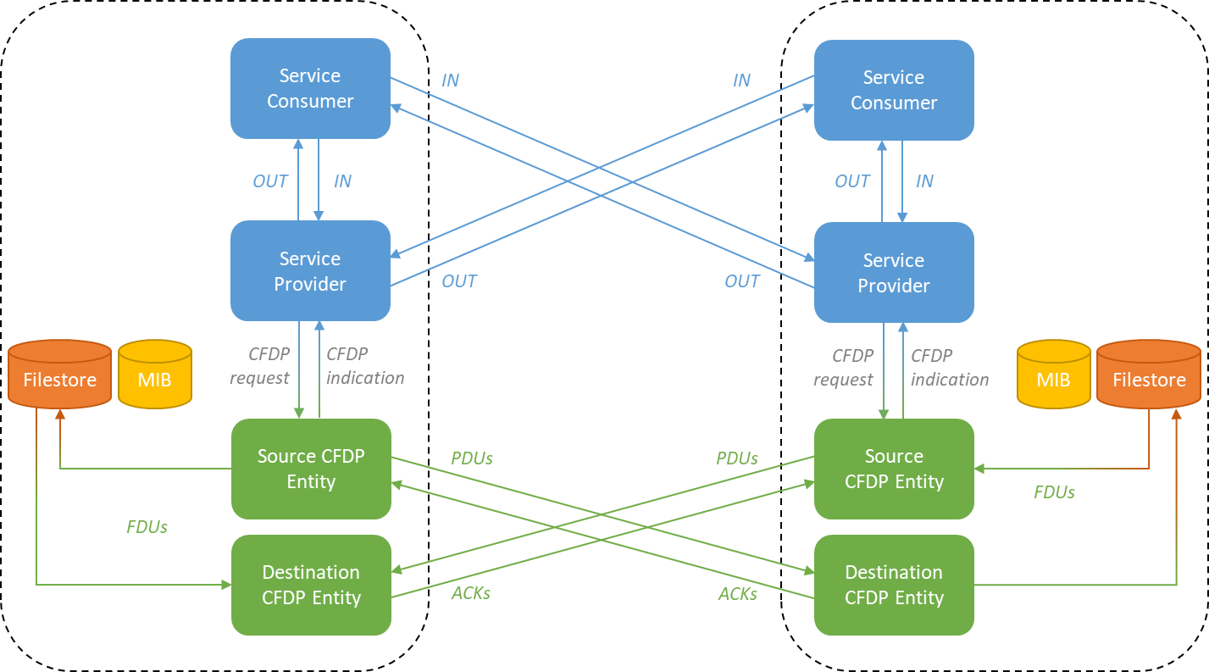

Figure 2-3: Scenario 2 - full-scale point-to-point
Scenario 3 simplifies the second scenario for a typical ground-space setup. In this case the Mission Operation Centre (left) can transfer files from its local filestore to the remote filestore, and from the remote filestore to its local filestore. The spacecraft (right) implements only the provider side. All file transfers are initiated and controlled from the MOC.

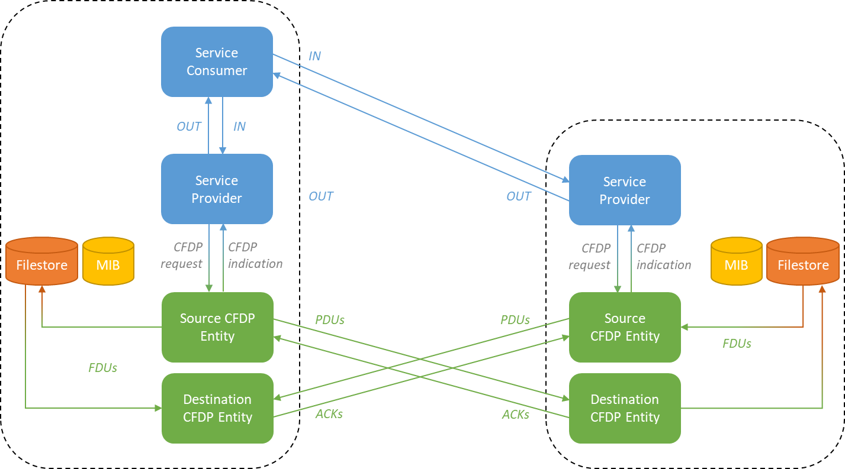
Figure 2-4: Scenario 3 - full-scale point-to-point for typical ground-space setup, with the Mission Operations Centre on the left and the spacecraft on the right.

Scenario 4 takes the basic setup in the first scenario and adds CFDP store-and-forward. This scenario still assumes a direct connection between the consumer and the provider.

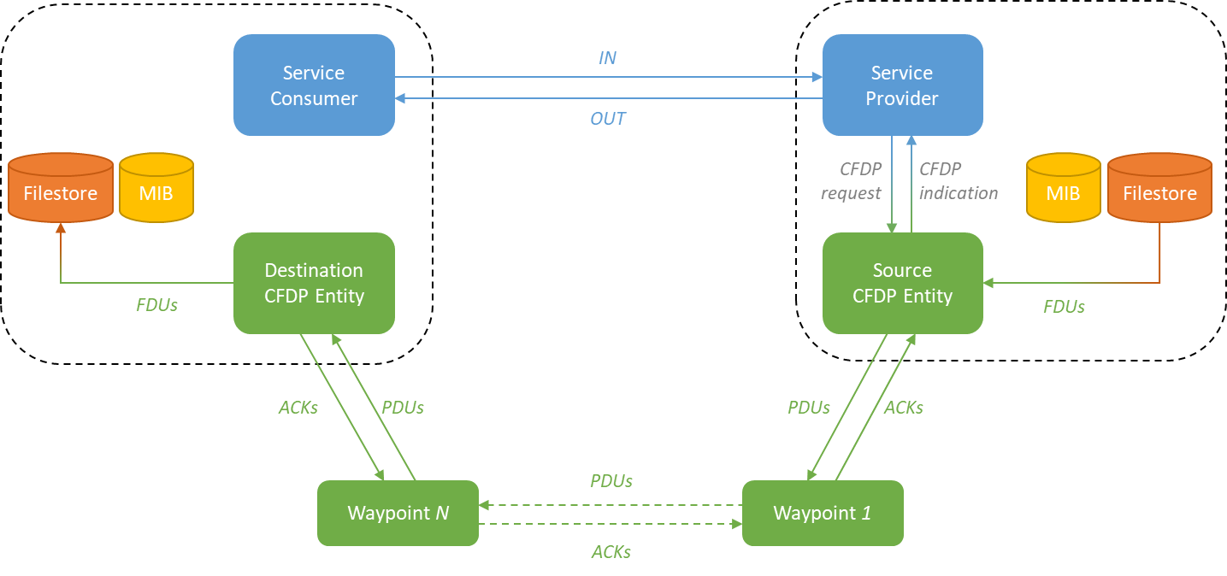

Figure 2-5: Scenario 4 - basic point-to-point setup with CFDP store-and-forward

Scenario 5 extends the fourth scenario to include as well MO action forwarding.
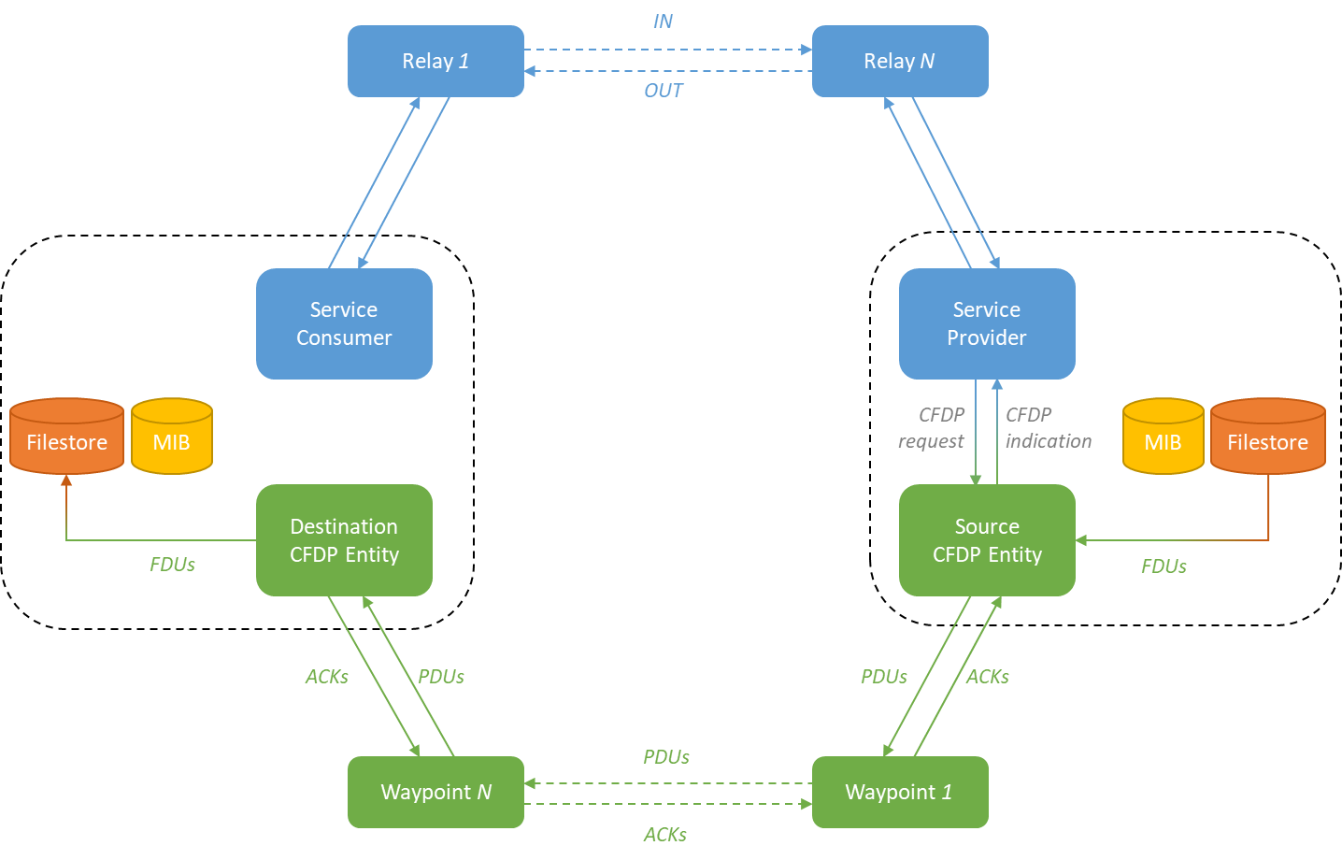

Figure 2-6: Scenario 5 - basic setup with Mission Operations action forwarding and CFDP store-and-forward

Scenario 6 considers yet another situation where the service consumer is not the source or destination of the file being transferred. This would be the case, for example, when the Mission Operations Centre transfers a file from an orbiting satellite to a surface rover.

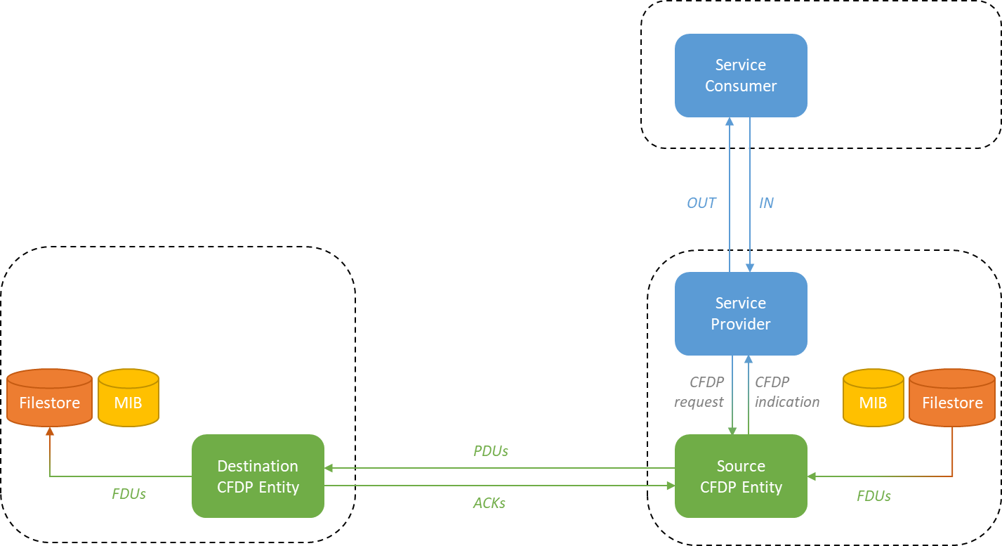
Figure 2-7: Scenario 6 – basic point-to-point setup but for the case when the consumer is not the CFDP source or the destination of the file.

Service Specifications

General
TBW

Service: File System

General
The File System service gives consumers the capabilities to manage files on a remote file system.
It is not content aware, and manipulates files as black boxes. It allows controlling flat (i.e. without support for directories) or structured (i.e. with directory support) file systems by providing functionalities to manage files and directories.
File usage is not within the scope of this service. MO services that can use files have dedicated subtypes supporting the utilization of files within their context.
File transfers that require the file to leave the file system (e.g. transfer over a space link) are out of the scope of this service and are handled by the File Transfer Service detailed in section 3.3.
Table 3-22: File System Service Operations
Area Identifier | Service Identifier | Area Number | Service Number | Area Version
FM | FileSystem | 30 | 29 | 1
Interaction Pattern | Operation Identifier | Operation Number | Support in Replay | Capability Set
SUBMIT | create | 1 | No | 1
SUBMIT | move | 2 | No | 1
SUBMIT | delete | 3 | No | 1
SUBMIT | copy | 4 | No | 1
REQUEST | getAttributes | 5 | No | 2
SUBMIT | setAttributes | 6 | No | 2
REQUEST | list | 7 | No | 3
PROGRESS | find | 8 | No | 3
REQUEST | append | 9 | No | 4
SUBMIT | truncate | 10 | No | 4
REQUEST | read | 11 | No | 4

High Level requirements
TBW

Functional Requirements
TBW

COM Usage
TBW

COM Event Service Usage
TBW

COM Archive Service Usage
TBW

Operation: create

General
The create operation allows a consumer to create a new empty file or directory on a remote filestore. This operation will create the file or directory with the default attributes of the remote file system. To change the attributes of files or directories refer to operation setAttributes.
Operation Identifier | create
Interaction Pattern | SUBMIT
Pattern Sequence | Message | Body Type
IN | SUBMIT | type : (NodeType)  path : (MAL::URI)  overwrite : (MAL::Boolean)

Structures
- If the overwrite field is set to TRUE and a file/directory with the same path already exists, then the existing file/directory shall be deleted and a new empty file/directory created.

Errors
- If the consumer does not have the permissions to create a new file or directory on the remote file system, then the provider shall return the error PERMISSION_DENIED.
- If path does not correspond to a valid file or directory path on the remote file system, then the provider shall return the error INVALID_PATH. The extra information field shall report the URI of path.
- If the overwrite field is set to FALSE and the file/directory already exists, then the provider shall return the error NODE_EXISTS. The extra information field shall report the path.
- If type is not a FILE or a DIRECTORY, then the provider shall return the error UNKNOWN_NODE_TYPE. The extra information field shall report the type.
- The error OTHER shall be used to report other errors specific to the remote file system and that are not covered by this standard. The error details shall be reported in the error extra information field.

Operation: move

General
The move operation allows a consumer to move (i.e. rename) a file or directory from the source to the target path within a remote filestore (even if across different file systems). Operations to move a file across different filestores over the space link are covered by the File Transfer Service (section 3.3).
Operation Identifier | move
Interaction Pattern | SUBMIT
Pattern Sequence | Message | Body Type
IN | SUBMIT | source : (MAL::URI)  target : (MAL::URI)  overwrite : (MAL::Boolean)

Structures
- If the overwrite field is set to TRUE and a file/directory with the same target path already exists, then the existing file/directory shall be overwritten.

Errors
- If the overwrite field is set to FALSE and target already exists, then the provider shall return the error NODE_EXISTS. The extra information field shall report the path of the target.
- If the consumer does not have the permissions to create a new file or directory on the remote file system, then the provider shall return the error PERMISSION_DENIED.
- If source does not correspond to a valid file or directory path on the remote file system, then the provider shall return the error INVALID_PATH. The extra information field shall report the path of the source.
- If target does not correspond to a valid file or directory path on the remote file system, then the provider shall return the error INVALID_PATH. The extra information field shall report the path of the target.
- If source does not exist, then the provider shall return the error NODE_NOT_FOUND. The extra information field shall report the URI of the source.
- If there is not enough space to move (rename) source to target, then the provider shall return the error FILESYSTEM_FULL.
- The error OTHER shall be used to report other errors specific to the remote file system and that are not covered by this standard. The error details shall be reported in the error extra information field.

Operation: delete

General
The delete operation allows a consumer to delete a file or directory from a remote filestore.
Operation Identifier | delete
Interaction Pattern | SUBMIT
Pattern Sequence | Message | Body Type
IN | SUBMIT | path : (MAL::URI)  force : (MAL::Boolean)

Structures
- If the force field is TRUE and the path points to a directory then all nested files and folders shall also be deleted.
- If the force field is FALSE and the path points to a directory then the directory shall only be deleted if empty.

Errors
- If the force field is FALSE and the path points to a directory and the directory is not empty, then the provider shall return the error DIRECTORY_NOT_EMPTY. The extra information field shall report the URI of path.
- If the consumer does not have the permissions to delete the file or directory on the remote file system, then the provider shall return the error PERMISSION_DENIED.
- If path does not correspond to a valid file or directory path on the remote file system, then the provider shall return the error INVALID_PATH. The extra information field shall report the URI of path.
- If path does not exist, then the provider shall return the error NODE_NOT_FOUND. The extra information field shall report the URI of the path.
- If path is not a FILE or a DIRECTORY, then the provider shall return the error UNKNOWN_NODE_TYPE. The extra information field shall report the URI of path.
- The error OTHER shall be used to report other errors specific to the remote file system and that are not covered by this standard. The error details shall be reported in the error extra information field.

Operation: copy

General
The copy operation allows a consumer to copy a file or directory from the source to the target path within a remote filestore (even if across different file systems). Operations to copy a file across different filestores over the space link are covered by the File Transfer Service (section 3.3).
Operation Identifier | copy
Interaction Pattern | SUBMIT
Pattern Sequence | Message | Body Type
IN | SUBMIT | source : (MAL::URI)  target : (MAL::URI)  overwrite : (MAL::Boolean)

Structures
- If the overwrite field is set to TRUE and a file/directory with the same target path already exists, then the existing file/directory shall be overwritten.

Errors
- If the overwrite field is set to FALSE and target already exists, then the provider shall return the error NODE_EXISTS. The extra information field shall report the URI of the target.
- If the consumer does not have the permissions to create a new file or directory on the remote file system, then the provider shall return the error PERMISSION_DENIED.
- If source does not correspond to a valid file or directory path on the remote file system, then the provider shall return the error INVALID_PATH. The extra information field shall report the URI of the source.
- If target does not correspond to a valid file or directory path on the remote file system, then the provider shall return the error INVALID_PATH. The extra information field shall report the URI of the target.
- If source does not exist, then the provider shall return the error NODE_NOT_FOUND. The extra information field shall report the URI of the source.
- If there is not enough space to move (rename) source to target, then the provider shall return the error FILESYSTEM_FULL.
- The error OTHER shall be used to report other errors specific to the remote file system and that are not covered by this standard. The error details shall be reported in the error extra information field.

Operation: getAttributes

General
The getAttributes operation allows a consumer to read out a set attributes of a file or directory on a remote file system. These include, for example, size, permission rights or last access time.
Operation Identifier | getAttributes
Interaction Pattern | REQUEST
Pattern Sequence | Message | Body Type
IN | REQUEST | path : (MAL::URI)
OUT | RESPONSE | attributes : (NodeAttributes)

Structures

Errors
- If the consumer does not have the permissions to access the remote file system, then the provider shall return the error PERMISSION_DENIED.
- If path does not correspond to a valid file or directory path on the remote file system, then the provider shall return the error INVALID_PATH. The extra information field shall report the URI of path.
- If path does not exist, then the provider shall return the error NODE_NOT_FOUND. The extra information field shall report the URI of the path.
- The error OTHER shall be used to report other errors specific to the remote file system and that are not covered by this standard. The error details shall be reported in the error extra information field.

Operation: setAttributes

General
The setAttributes operation allows a consumer to modify some attributes of a file or directory on a remote file system. In the current implementation the consumer can modify the access permissions and ownership.
Operation Identifier | setAttributes
Interaction Pattern | SUBMIT
Pattern Sequence | Message | Body Type
IN | SUBMIT | path : (MAL::URI)  attributes : (NodeAttributes)

Structures
- The attributes field shall be used to specify which attributes shall be set and to which values.

Errors
- If the consumer does not have the permissions to access the remote file system, then the provider shall return the error PERMISSION_DENIED.
- If path does not correspond to a valid file or directory path on the remote file system, then the provider shall return the error INVALID_PATH. The extra information field shall report the URI of path.
- If path does not exist, then the provider shall return the error NODE_NOT_FOUND. The extra information field shall report the URI of path.
- Only the settable fields in attributes should be specified by the consumer. Non-settable fields type shall be ignored by the provider. See NodeAttributes for which attributes are settable.
- If a consumer tries to set non settable attributes, then the provider shall:
  - Set all the attributes that can be set;
  - Return with error INVALID_ATTRIBUTE. The extra information field shall contain a NodeAttributes object reporting the attributes that could not be set.
- The error OTHER shall be used to report other errors specific to the remote file system and that are not covered by this standard. The error details shall be reported in the error extra information field.

Operation: list

General
The list operation allows a consumer to list the files and directories in a given directory on the remote file system. This listing allows for filtering based on name and time and it is not recursive.
Operation Identifier | list
Interaction Pattern | REQUEST
Pattern Sequence | Message | Body Type
IN | REQUEST | path : (MAL::URI)  toFile : (MAL::Boolean)  nameRegexFilter : (MAL::String)  lastModifiedTimeFilter : (MAL::Time)
OUT | RESPONSE | nodes : (List<Node>)

Structures
- If the toFile field is TRUE, then the output of the list operation shall be written to a file. In this case the RESPONSE field nodes contains a single entry with the path to the file where the list has been written to. The exact name, format and content of this file is deployment specific, and as such is outside the scope of this standard and is expected to be agreed out of band.
- The field nameRegexFilter may be used to filter the files and directories by name using a regular expression. All files and directories for which the regular expression holds true will be added to the list.
- The field lastModifiedTimeFilter may be used to filter the files and directories by last modified time. All files and directories with last modified time greater than or equal to the filter will be added to the list.
- The field nodes in the RESPONSE holds a list with all the files and directories in path that, optionally, match nameRegexFilter and/or lastModifiedTimeFilter.
- The specification of the regular expression standard to use is deployment specific, and as such is outside the scope of this standard and is expected to be agreed out of band.

Errors
- If the toFile is TRUE but the provider cannot write to the output file, then the provider shall return the error IO_ERROR. The extra information field may report the exact error.
- If the consumer does not have the permissions to access the remote file system, then the provider shall return the error PERMISSION_DENIED.
- If path does not correspond to a valid file or directory path on the remote file system, then the provider shall return the error INVALID_PATH. The extra information field shall report the URI of path.
- If path does not exist, then the provider shall return the error NODE_NOT_FOUND. The extra information field shall report the URI of path.
- If path does not point to a directory, then the provider shall return the error NOT_A_DIRECTORY. The extra information field shall report the URI of path.
- The error OTHER shall be used to report other errors specific to the remote file system and that are not covered by this standard. The error details shall be reported in the error extra information field.

Operation: find

General
The find operation allows a consumer to find files or folders in a search path on a remote file system that match a given regular expression.
Operation Identifier | find
Interaction Pattern | PROGRESS
Pattern Sequence | Message | Body Type
IN | PROGRESS | path : (MAL::URI)  toFile : (MAL::Boolean)  searchPattern : (MAL::String)
OUT | ACK | -
OUT | UPDATE | nodes : (List<Node>)
OUT | RESPONSE | count : (MAL::UInteger)

Structures
- The path field indicates the location on the file system from where the search shall be done.
- If the toFile field is TRUE, then the output of the find operation shall be written to a file. In this case the UPDATE field nodes contains a single entry with the path to the file where the output of the find has been written to. The exact name, format and content of this file is deployment specific, and as such is outside the scope of this standard and is expected to be agreed out of band.
- The field searchPattern is a regular expression shall be used to define the search pattern using a regular expression. All files and directories for which this search pattern holds true will be added to the find list.
- The specification of the regular expression standard to use is deployment specific, and as such is outside the scope of this standard and is expected to be agreed out of band.
- The field nodes in the UPDATE holds a list with all the files and directories found in path that match the searchPattern.
- The field count in the RESPONSE holds the total number files and directories found that match the searchPattern.

Errors
- If the toFile is TRUE but the provider cannot write to the output file, then the provider shall return the error IO_ERROR. The extra information field may report the exact error.
- If the consumer does not have the permissions to access the remote file system, then the provider shall return the error PERMISSION_DENIED.
- If path does not correspond to a valid path on the remote file system, then the provider shall return the error INVALID_PATH. The extra information field shall report the URI of path.
- If path does not exist, then the provider shall return the error NODE_NOT_FOUND. The extra information field shall report the URI of path.
- If path does not point to a directory, then the provider shall return the error NOT_A_DIRECTORY. The extra information field shall report the URI of path.
- The error OTHER shall be used to report other errors specific to the remote file system and that are not covered by this standard. The error details shall be reported in the error extra information field.

Operation: append

General
The append operation allows a consumer to append a blob of data to the end of an existing file on the remote file system.
Operation Identifier | append
Interaction Pattern | REQUEST
Pattern Sequence | Message | Body Type
IN | REQUEST | path : (MAL::URI)  data : (MAL::Blob)
OUT | RESPONSE | size : (MAL::ULong)

Structures
- The size field in the RESPONSE shall hold the total size of the file after the append operation.

Errors
- If the consumer does not have the permissions to access the remote file system, then the provider shall return the error PERMISSION_DENIED.
- If path does not correspond to a valid path on the remote file system, then the provider shall return the error INVALID_PATH. The extra information field shall report the URI of path.
- If path does not exist, then the provider shall return the error NODE_NOT_FOUND. The extra information field shall report the URI of path.
- If path does not point to a file, then the provider shall return the error NOT_A_FILE. The extra information field shall report the URI of path.
- If the provider cannot write to the file indicated by path, then the provider shall return the error IO_ERROR. The extra information field may report the exact error.
- The error OTHER shall be used to report other errors specific to the remote file system and that are not covered by this standard. The error details shall be reported in the error extra information field.

Operation: truncate

General
The truncate operation allows a consumer to delete the contents of a file on the remote file system (i.e. truncates the size to zero byte).
Operation Identifier | truncate
Interaction Pattern | SUBMIT
Pattern Sequence | Message | Body Type
IN | SUBMIT | path : (MAL::URI)

Structures

Errors
- If the consumer does not have the permissions to access the remote file system, then the provider shall return the error PERMISSION_DENIED.
- If path does not correspond to a valid path on the remote file system, then the provider shall return the error INVALID_PATH. The extra information field shall report the URI of path.
- If path does not exist, then the provider shall return the error NODE_NOT_FOUND. The extra information field shall report the URI of path.
- If path does not point to a file, then the provider shall return the error NOT_A_FILE. The extra information field shall report the URI of path.
- If the provider cannot write to the file indicated by path, then the provider shall return the error IO_ERROR. The extra information field may report the exact error.
- The error OTHER shall be used to report other errors specific to the remote file system and that are not covered by this standard. The error details shall be reported in the error extra information field.

Operation: read

General
The read operation allows a consumer to read a blob of data from a file on the remote file system. The operation allows the user to specify the location in the file from where to read (offset), as well as the number of bytes to read (size).
Operation Identifier | read
Interaction Pattern | REQUEST
Pattern Sequence | Message | Body Type
IN | REQUEST | path : (MAL::URI)  offset : (MAL::ULong)  size : (MAL::ULong)
OUT | RESPONSE | data : (MAL::Blob)

Structures
- The offset field may be used to specify the offset, in byte, from the start of the file. If Null then zero shall be assumed.
- The size field may be used to specify the amount of data, in byte, to read. If Null then the whole data from offset until end-of-file shall be read.

Errors
- If the consumer does not have the permissions to access the remote file system, then the provider shall return the error PERMISSION_DENIED.
- If path does not correspond to a valid path on the remote file system, then the provider shall return the error INVALID_PATH. The extra information field shall report the URI of path.
- If path does not exist, then the provider shall return the error NODE_NOT_FOUND. The extra information field shall report the URI of path.
- If path does not point to a file, then the provider shall return the error NOT_A_FILE. The extra information field shall report the URI of path.
- If the provider cannot read from the file indicated by path, then the provider shall return the error IO_ERROR. The extra information field may report the exact error.
- The error OTHER shall be used to report other errors specific to the remote file system and that are not covered by this standard. The error details shall be reported in the error extra information field.

Service: File Transfer

General
The File Transfer Service gives consumers the capabilities to control and monitor file transfers across the space link.
This service assumes the use of the CCSDS File Delivery Protocol (CFDP) [D5] as the underlying file delivery mechanism (TBC - see issue 1 in ANNEX E).
Table 3-33: File Transfer Service Operations
Area Identifier | Service Identifier | Area Number | Service Number | Area Version
FT | FileTransfer | 30 | 30 | 1
Interaction Pattern | Operation Identifier | Operation Number | Support in Replay | Capability Set
INVOKE | start | 1 | No | 1
SUBMIT | cancel | 2 | No | 1
SUBMIT | suspend | 3 | No | 1
SUBMIT | resume | 4 | No | 1
SUBMIT | cancelAll | 5 | No | 2
SUBMIT | suspendAll | 6 | No | 2
SUBMIT | resumeAll | 7 | No | 2
REQUETS | getTransactionReport | 8 | No | 3
REQUEST | listTransactions | 9 | No | 3
REQUEST | getWindowStatus | 10 | No | 3

High Level requirements
TBW

Functional Requirements
TBW

COM Usage
TBW

COM Event Service Usage
TBW

COM Archive Service Usage

TBW

Operation: start

General
The start operation allows a consumer to initiate a file transaction from the service provider to the consumer. This operation wraps the CFDP Put Request Primitive.
Operation Identifier | start
Interaction Pattern | INVOKE
Pattern Sequence | Message | Body Type
IN | INVOKE | sourcePath : (MAL::URI)  targetEntityId : (MAL::Blob)  targetPath : (MAL::URI)  priority : (MAL::UOctet)  transmissionWindowMode : (FileTransmissionMode)
OUT | ACK | transactionId : (FileTransactionId)
OUT | RESPONSE | transactionReport : (FileTransactionReport)

Structures
- The connectionDetails field shall be used to configure the connection for this transfer:
  - The priority field shall be set to a value in the range [1, 10] to set the priority of the transfer. The lower the number the higher the priority.
  - The transmissionWindowClass field may be set to configure the transmission mode. If Null the default value in the provider’s CFDP Management Information Base (MIB) shall be used.
  - All other fields shall be ignored.
- The transactionId field shall report the identifier of the just initiated transfer.
- The RESPONSE stage shall be issued once the transaction has finished (TBC – see ANNEX E).
- The transactionReport field shall provide a summary report of the just finished transaction, where:
  - The transactionId field shall be set to the transaction ID of the just finished transfer.
  - The transactionStatus field shall be set to indicate the status of just finished transfer. Nominally the field should read “TERMINATED”.
  - The transactionResponseCode field shall be set to indicate the success or not of the just finished transfer. Nominally the field should read “SUCCESSFUL”.
  - The sourcePath and the targetpath are the sourcePath and the targetPath in the INVOKE message.

Errors
- If the consumer does not have the permissions to access the remote file system, then the provider shall return the error PERMISSION_DENIED.
- If sourcePath does not correspond to a valid path on the remote file system, then the provider shall return the error INVALID_PATH. The extra information field shall report the URI of sourcePath.
- If sourcePath does not exist, then the provider shall return the error NODE_NOT_FOUND. The extra information field shall report the URI of sourcePath.
- If sourcePath does not point to a file, then the provider shall return the error NOT_A_FILE. The extra information field shall report the URI of sourcePath.
- If targetEntityId is not known to the provider, i.e. it is not in the provider’s MIB, then the provider shall return the error UNKNOWN_ENTITY. The extra information field shall report the targetEntityId.
- The error OTHER shall be used to report other errors specific to the remote file system and that are not covered by this standard. The error details shall be reported in the error extra information field.

Operation: cancel

General
The cancel operation allows a consumer to cancel an ongoing transaction. This operation wraps the CFDP Cancel Request Primitive.
Operation Identifier | cancel
Interaction Pattern | SUBMIT
Pattern Sequence | Message | Body Type
IN | SUBMIT | transactionId : (FileTransactionId)

Structures

Errors
- If transactionId is not known to the provider, then the provider shall return the error UNKNOWN_TRANSACTION. The extra information field shall report the transactionId.
- The error OTHER shall be used to report other errors specific to the remote file system and that are not covered by this standard. The error details shall be reported in the error extra information field.

Operation: suspend

General
The suspend operation allows a consumer to suspend an ongoing transfer. This operation wraps the CFDP Suspend Request Primitive.
Operation Identifier | suspend
Interaction Pattern | SUBMIT
Pattern Sequence | Message | Body Type
IN | SUBMIT | transactionId : (FileTransactionId)

Structures

Errors
- If transactionId is not known to the provider, then the provider shall return the error UNKNOWN_TRANSACTION. The extra information field shall report the transactionId.
- The error OTHER shall be used to report other errors specific to the remote file system and that are not covered by this standard. The error details shall be reported in the error extra information field.

Operation: resume

General
The resume operation allows a consumer to resumes a previously suspended transaction. This operation wraps the CFDP Resume Request Primitive.
Operation Identifier | resume
Interaction Pattern | SUBMIT
Pattern Sequence | Message | Body Type
IN | SUBMIT | transactionId : (FileTransactionId)

Structures

Errors
- If transactionId is not known to the provider, then the provider shall return the error UNKNOWN_TRANSACTION. The extra information field shall report the transactionId.
- The error OTHER shall be used to report other errors specific to the remote file system and that are not covered by this standard. The error details shall be reported in the error extra information field.

Operation: cancelAll

General
The cancelAll operation allows a consumer to cancel all ongoing transactions. This operation applies the CFDP Cancel Request Primitive on all ongoing transactions for a given entity.
Operation Identifier | cancelAllTransfers
Interaction Pattern | SUBMIT
Pattern Sequence | Message | Body Type
IN | SUBMIT | -

Structures

Errors
- The error OTHER shall be used to report other errors specific to the remote file system and that are not covered by this standard. The error details shall be reported in the error extra information field.

Operation: suspendAll

General
The suspendAll operation allows a consumer to suspends all ongoing transactions from and/or to a given entity. This operation applies the CFDP Suspend Request Primitive on all ongoing transactions to/from a user-defined entity.
Operation Identifier | suspendAll
Interaction Pattern | SUBMIT
Pattern Sequence | Message | Body Type
IN | SUBMIT | entityId : (MAL::Blob)  window : (FileTransferWindow)

Structures
- The entityId field shall be used to indicate the remote entity to/from which to suspend ongoing transactions.
- The window field shall be set to either:
  - TX_WINDOW, to suspend all transactions to the entity with ID entityId
  - RX_WINDOW, to suspend all transactions from the entity with ID entityId.
  - BOTH_WINDOW, to suspend all transactions to and from the entity with ID entityID.
- To suspend the transactions the provider shall set the window, as specified by the operation field window, to FALSE in the provider’s MIB.

Errors
- If entityId is not known to the provider, i.e. it is not in the provider’s MIB, then the provider shall return the error UNKNOWN_ENTITY. The extra information field shall report the entityId.
- If the provider cannot set the values in the MIB, then it shall return the error CANNOT_SET_MIB_VALUE.
- The error OTHER shall be used to report other errors specific to the remote file system and that are not covered by this standard. The error details shall be reported in the error extra information field.

Operation: resumeAll

General
The resumeAll operation allows a consumer to resume previously suspended transactions from and/or to a given entity. This operation applies the CFDP Resume Request Primitive on all suspended transactions to/from a user-defined entity.
Operation Identifier | resumeAll
Interaction Pattern | SUBMIT
Pattern Sequence | Message | Body Type
IN | SUBMIT | entityId : (MAL::Blob)  window : (FileTransferWindow)

Structures
- The entityId field shall be used to indicate the remote entity to/from which to resume the suspended transaction.
- The window field shall be set to either:
  - TX_WINDOW, to resume all transactions to the entity with ID entityId
  - RX_WINDOW, to resume all transactions from the entity with ID entityId.
  - BOTH_WINDOW, to resume all transactions to and from the entity with ID entityID.
- To resume the transactions the provider shall set the window, as specified by the operation field window, to TRUE in the provider’s MIB.

Errors
- If entityId is not known to the provider, i.e. it is not in the provider’s MIB, then the provider shall return the error UNKNOWN_ENTITY. The extra information field shall report the entityId.
- If the provider cannot set the values in the MIB, then it shall return the error CANNOT_SET_MIB_VALUE.
- The error OTHER shall be used to report other errors specific to the remote file system and that are not covered by this standard. The error details shall be reported in the error extra information field.

Operation: getTransactionReport

General
The getTransactionReport operation allows a consumer to request a report on the status of a transaction. This operation wraps the CFDP Report Request Primitive.
Operation Identifier | getTransactionReport
Interaction Pattern | REQUEST
Pattern Sequence | Message | Body Type
IN | REQUEST | transactionId : (FileTransactionId)
OUT | RESPONSE | report : (FileTransactionReport)

Structures
- The report field shall provide a summary report of the transaction:
  - The transactionId field shall be set to the transaction ID.
  - The transactionStatus field shall be set to indicate the current status of the transaction.
  - The transactionResponseCode field shall be set to indicate the success or not of the transaction.
  - The sourcePath and the targetpath are the sourcePath and the targetPath in the INVOKE message.

Errors
- If transactionId is not known to the provider, then the provider shall return the error UNKNOWN_TRANSACTION. The extra information field shall report the transactionId.
- The error OTHER shall be used to report other errors specific to the remote file system and that are not covered by this standard. The error details shall be reported in the error extra information field.

Operation: listTransactions

General
The listTransactions operation allows a consumer to list all ongoing or pending transactions to/from a given entity.
Operation Identifier | listTransactions
Interaction Pattern | REQUEST
Pattern Sequence | Message | Body Type
IN | REQUEST | entityId : (MAL::Blob)
OUT | RESPONSE | transactionList : (List<FileTransactionReport>)

Structures
- The entityId field shall be used to indicate the remote entity for which to report all ongoing or pending transfers.
- The RESPONSE message shall return a list of FileTransactionReport objects with one entry per pending or ongoing transaction.
  - The transactionId field shall be set to the transaction ID.
  - The transactionStatus field shall be set to indicate the current status of the transaction.
  - The transactionResponseCode field shall be set to indicate the success or not of the transaction. For pending and ongoing transactions this field shall be set to UNKNOWN.
  - The sourcePath and the targetpath are the sourcePath and the targetPath in the INVOKE message.

Errors
- If entityId is not known to the provider, i.e. it is not in the provider’s MIB, then the provider shall return the error UNKNOWN_ENTITY. The extra information field shall report the entityId.
- The error OTHER shall be used to report other errors specific to the remote file system and that are not covered by this standard. The error details shall be reported in the error extra information field.

Operation: getWindowStatus

General
The getWindowStatus operation allows a consumer to get the current status of the receive and transmit windows for a given entity.
Operation Identifier | getWindowStatus
Interaction Pattern | REQUEST
Pattern Sequence | Message | Body Type
IN | REQUEST | entityId : (MAL::Blob)
OUT | RESPONSE | txWindowOpen : (MAL::Boolean)  rxWindowOpen : (MAL::Boolean)

Structures
- The entityId field shall be used to indicate the remote entity for which to report the status.
- The txWindowOpen field shall be set to TRUE if the transmit window to the entity with ID entityId is open, and FALSE if closed.
- The rxWindowOpen field shall be set to TRUE if the receive window from the entity with ID entityId is open, and FALSE if closed.

Errors
- If entityId is not known to the provider, i.e. it is not in the provider’s MIB, then the provider shall return the error UNKNOWN_ENTITY. The extra information field shall report the entityId.
- If the provider cannot get the values from the MIB, then it shall return the error CANNOT_GET_MIB_VALUE.
- The error OTHER shall be used to report other errors specific to the remote file system and that are not covered by this standard. The error details shall be reported in the error extra information field.

Data Types

Service Data Types: FILE SYSTEM

Composite: NodeAttributes
The NodeAttributes composite holds the attributes for the remote file or directory.
Name | NodeAttributes
Extends | MAL::Composite
Short Form Part | 1
Field | Type | Nullable | Comment
type | NodeType | Yes | Settable: no
size | MAL::ULong | Yes | Settable: no  Size of the file or directory in Kibibyte (1024 byte)
accessPermissions | MAL:: String | Yes | Settable: yes
owner | MAL:: String | Yes | Settable: yes
creationTime | MAL:: String | Yes | Settable: no
lastAccessTime | MAL:: String | Yes | Settable: no
lastChangeTime | MAL:: String | Yes | Settable: no
lastModificationTime | MAL:: String | Yes | Settable: no

Enumeration: nodeType
The NodeType enumeration holds the possible node types.
Name | NodeType
Short Form Part | 2
Field | Numerical Value | Comment
FILE | 1
DIRECTORY | 2

Composite: Node
The Node composite holds metadata about a file or directory in the file system.
Name | Node
Extends | MAL::Composite
Short Form Part | 3
Field | Type | Nullable | Comment
type | NodeType | No
size | MAL::ULong | No | Size of the node in Kibibyte (1024 byte)
path | MAL::URI | No

Service Data Types: FILE TRANSFER

Composite: TranSACTIONAttributes
The TransactionAttributes holds all the possible attributes for a remote file transfer.
Name | TransactionAttributes
Extends | MAL::Composite
Short Form Part | 1
Field | Type | Nullable | Comment
transmissionWindowMode | FileTransmissionMode | Yes
receptionWindowMode | FileTransmissionMode | Yes
transactionStatus | FileTransactionStatus | Yes | Settable: no
transactionResponseCode | FileTransactionResponseCode | Yes | Settable: no
transactionId | FileTransactionId | Yes | Settable: no
maxTransmissionSpeed | MAL::Float | Yes | Settable: yes
maxReceptionSpeed | MAL::Float | Yes | Settable: yes
priority | MAL::UOctet | Yes | Settable: yes  The request priority in the range [1,10]. The lower the number the higher the priority.

Composite: FileTransactionId
The ID of the File Delivery Unit (FDU) transaction. A single transaction usually entails the transmission and reception of multiple Protocol Delivery Units (PDUs).
Name | FileTransactionId
Extends | MAL::Composite
Short Form Part | 2
Field | Type | Nullable | Comment
entity | MAL::String | No
id | MAL::Blob | No | The ID as a byte array (Blob)

Enumeration: FileTransmissionMode
Name | FileTransmissionMode
Short Form Part | 3
Field | Numerical Value | Comment
UNRELIABLE | 1 | Unacknowledged mode
RELIABLE | 2 | Acknowledged mode

Enumeration: FileTransactionStatus
Name | FileTransactionStatus
Short Form Part | 4
Field | Numerical Value | Comment
UNDEFINED | 1
ACTIVE | 2
TERMINATED | 3
UNRECOGNISED | 4
UNKNOWN | 5

Enumeration: FileTransactionResponseCode
Name | FileTransactionResponseCode
Short Form Part | 5
Field | Numerical Value | Comment
UNSUCCESSFUL | 1
SUCCESSFUL | 2
UNKNOWN | 3

Enumeration: FileTransferWindow
Name | FileTransferWindow
Short Form Part | 6
Field | Numerical Value | Comment
TX_WINDOW | 1
RX_WINDOW | 2
BOTH_WINDOW | 3

Composite: FileTransactionReport
Name | FileTransactionReport
Extends | MAL::Composite
Short Form Part | 7
Field | Type | Nullable | Comment
transactionId | FileTransactionId | No
transactionStatus | FileTransactionStatus | No
transactionResponseCode | FileTransactionResponseCode | No
sourcePath | MAL::URI | No
targetPath | MAL::URI | No

Error Codes

General
Table 5-44: Overview of the File System Service Error Codes
Error | Error # | Comment
PERMISSION_DENIED | 80001 | The consumer does not have the right permissions to perform the operation on the remote file or directory
FILESYSTEM_FULL | 80002 | The operation could not be performed because the remote file system is full
INVALID_PATH | 80003 | The path to the remote file or directory provided by the consumer is invalid
NODE_NOT_FOUND | 80004 | The path to the remote file or directory provided by the consumer does not exist
OTHER | 80005 | Other system-specific error reported by the remote file system that is not covered in these specifications. See extra information for details

PERMISSION_DENIED
Error | Error # | ExtraInfo Type
PERMISSION_DENIED | 80001 | Not Used

FILESYSTEM_FULL
Error | Error # | ExtraInfo Type
FILESYSTEM_FULL | 80002 | Not Used

INVALID_PATH
Error | Error # | ExtraInfo Type
INVALID_PATH | 80003 | MAL::URI

NODE_NOT_FOUND
Error | Error # | ExtraInfo Type
NODE_NOT_FOUND | 80004 | MAL::URI

OTHER
Error | Error # | ExtraInfo Type
OTHER | 80005 | List<MAL::Attribute>

File System
Table 5-55: Overview of the File System Service Error Codes
Error | Error # | Comment
NODE_EXISTS | 80010 | The path to the remote file or directory provided by the consumer already exists
NODE_LOOP | 80011 | Recursive symbolic links (only applicable if the file system supports symbolic links)
NOT_A_DIRECTORY | 80012 | The node has been invoked as a directory but it is not a directory
NOT_A_FILE | 80013 | The node has been invoked as a file but it is not a file
UNKNOWN_NODE_TYPE | 80014 | The node is neither a file or a directory
DIRECTORY_NOT_EMPTY | 80015 | The consumer tried to delete a directory but the directory is not empty
INVALID_ATTRIBUTE | 80020 | One or more attributes set by the consumer are invalid. See extra information for details
IO_ERROR | 80030 | Could not read or write to file. See extra information for details

NODE_EXISTS
Error | Error # | ExtraInfo Type
NODE_EXISTS | 80010 | MAL::URI

NODE_LOOP
Error | Error # | ExtraInfo Type
NODE_LOOP | 80011 | Not Used

NOT_A_DIRECTORY
Error | Error # | ExtraInfo Type
NOT_A_DIRECTORY | 80012 | MAL::URI

NOT_A_FILE
Error | Error # | ExtraInfo Type
NOT_A_FILE | 80013 | MAL::URI

UNKNOWN_NODE_TYPE
Error | Error # | ExtraInfo Type
UNKNOWN_NODE_TYPE | 80014 | NodeType

DIRECTORY_NOT_EMPTY
Error | Error # | ExtraInfo Type
DIRECTORY_NOT_EMPTY | 80015 | MAL::URI

INVALID_ATTRIBUTE
Error | Error # | ExtraInfo Type
INVALID_ATTRIBUTE | 80020 | NodeAttributes

IO_ERROR
Error | Error # | ExtraInfo Type
IO_ERROR | 80030 | MAL::Attribute

File Transfer
Table 5-66: Overview of the File Transfer Service Error Codes
Error | Error # | Comment
TRANSACTION_ABORTED | 80040 | The file transaction has been aborted. See extra information for details
TRANSACTION_ALREADY_STARTED | 80041 | A start or resume operation was issued by the consumer but the transaction was already started
TRANSACTION_ALREADY_CANCELED | 80042 | A cancel request was received by the provider but the transaction was already canceled
TRANSACTION_ALREADY_SUSPENDED | 80043 | A suspend request was received by the provider but the transaction was already suspended
UNKNOWN_TRANSACTION | 80044 | The transaction referenced by the consumer is not known to the provider
UNKNOWN_ENTITY | 80045 | The entity referenced by the consumer is not known to the provider
CANNOT_SET_MIB_VALUE | 80050 | Could not set the value in the CFDP Management Information Base (MIB). See extra information for details
CANNOT_GET_MIB_VALUE | 80051 | Could not get the value in the CFDP Management Information Base (MIB). See extra information for details

TRANSACTION_ABORTED
Error | Error # | ExtraInfo Type
TRANSACTION_ABORTED | 80040 | FileTransactionId

TRANSACTION_ALREADY_STARTED
Error | Error # | ExtraInfo Type
TRANSACTION_ALREADY_STARTED | 80041 | FileTransactionId

TRANSACTION_ALREADY_CANCELED
Error | Error # | ExtraInfo Type
TRANSACTION_ALREADY_CANCELED | 80042 | FileTransactionId

TRANSACTION_ALREADY_SUSPENDED
Error | Error # | ExtraInfo Type
TRANSACTION_ALREADY_SUSPENDED | 80043 | FileTransactionId

UNKNOWN_TRANSACTION
Error | Error # | ExtraInfo Type
UNKNOWN_TRANSACTION | 80044 | FileTransactionId

UNKNOWN_ENTITY
Error | Error # | ExtraInfo Type
UNKNOWN_ENTITY | 80045 | MAL::Blob

CANNOT_SET_MIB_VALUE
Error | Error # | ExtraInfo Type
CANNOT_SET_MIB_VALUE | 80050 | MAL::Attribute

CANNOT_GET_MIB_VALUE
Error | Error # | ExtraInfo Type
CANNOT_GET_MIB_VALUE | 80051 | MAL::Attribute

XML Service Specifications
The following section defines the service in the XML notation as specified in reference [2].
The use of XML for service specification provides a machine-readable format rather than the text-based document format. The published specifications and XML schemas are held in an online SANA registry, located at:
[SANA Registry location to be supplied]
The normative XML for this specification, validated against the XML schemas, is located:
[SANA Registry location to be supplied]

Implementation Conformance
Statement (ICS) Proforma
(normative)
  - INTRODUCTION
    - OVERVIEW
This annex provides the Implementation Conformance Statement (ICS) Requirements List (RL) for an implementation of [Specification]. The ICS for an implementation is generated by completing the RL in accordance with the instructions below. An implementation claiming conformance must satisfy the mandatory requirements referenced in the RL.
    - ABBREVIATIONS AND CONVENTIONS
The RL consists of information in tabular form. The status of features is indicated using the abbreviations and conventions described below.
Item Column
The item column contains sequential numbers for items in the table.
Feature Column
The feature column contains a brief descriptive name for a feature. It implicitly means “Is this feature supported by the implementation?”
Status Column
The status column uses the following notations:
- M mandatory;
- O optional;
- C conditional;
- X prohibited;
- I out of scope;
- N/A not applicable.
Support Column Symbols
The support column is to be used by the implementer to state whether a feature is supported by entering Y, N, or N/A, indicating:
Y Yes, supported by the implementation.
N No, not supported by the implementation.
N/A Not applicable.
The support column should also be used, when appropriate, to enter values supported for a given capability.
    - INSTRUCTIONS FOR COMPLETING THE RL
An implementer shows the extent of compliance to the Recommended Standard by completing the RL; that is, the state of compliance with all mandatory requirements and the options supported are shown. The resulting completed RL is called an ICS. The implementer shall complete the RL by entering appropriate responses in the support or values supported column, using the notation described in A1.2. If a conditional requirement is inapplicable, N/A should be used. If a mandatory requirement is not satisfied, exception information must be supplied by entering a reference Xi, where i is a unique identifier, to an accompanying rationale for the noncompliance.
  - ICS PROFORMA FOR [SPECIFICATION]
    - GENERAL INFORMATION
      - Identification of ICS
Date of Statement (DD/MM/YYYY)
ICS serial number
System Conformance statement cross-reference
      - Identification of Implementation Under Test
Implementation Name
Implementation Version
Special Configuration
Other Information
      - Identification of Supplier
Supplier
Contact Point for Queries
Implementation Name(s) and Versions
Other information necessary for full identification, e.g., name(s) and version(s) for machines and/or operating systems;

System Name(s)
      - Identification of Specification
[CCSDS Document Number]
Have any exceptions been required?  NOTE – A YES answer means that the implementation does not conform to the Recommended Standard. Non-supported mandatory capabilities are to be identified in the ICS, with an explanation of why the implementation is non-conforming. | Yes [ ] No [ ]
    - REQUIREMENTS LIST
[See CCSDS A20.1-Y-1, CCSDS Implementation Conformance Statements (Yellow Book, Issue 1, April 2014).]

Security, SANA, and Patent Considerations
(Informative)
  - Security Considerations
    - security concerns with respect to the CCSDS document
      - Data Privacy

      - Data Integrity

      - Authentication of Communicating Entities

      - Control of Access to Resources

      - Availability of Resources

      - Auditing of Resource Usage

    - Potential threats and attack scenarios

    - Consequences of not applying security to the technology

  - SANA Considerations
[See CCSDS 313.0-Y-1, Space Assigned Numbers Authority (SANA)—Role, Responsibilities, Policies, and Procedures (Yellow Book, Issue 1, July 2011).]
  - Patent Considerations
[See CCSDS A20.0-Y-4, CCSDS Publications Manual (Yellow Book, Issue 4, April 2014).]

Acronyms
(Informative)
API Application Program Interface
AMS CCSDS Asynchronous Messaging System
CCS Central Checkout System
CCSDS Consultative Committee for Space Data Systems
CFDP CCSDS File Delivery Protocol
COM Common Object Model
FBO File Based Operations
FDU File Delivery Unit
FM File Management
MAL Message Abstract Layer
M&C Monitor and Control
MCS Mission Control System
MIB Management Information Base
MO Mission Operations
PDU Protocol Data Unit
SDU Service Data Units
SPP CCSDS Space Packet Protocol
UML Unified Modeling Language
XML eXtensible Markup Language

Informative References
(Informative)
[D4] Mission Operations Services Concept. Issue 3. Report Concerning Space Data System Standards (Green Book), CCSDS 520.0-G-3. Washington, D.C.: CCSDS, December 2010.
[D5] CCSDS File Delivery Protocol (CFDP) – Part 1: Introduction and Overview. Issue 3. Report Concerning Space Data System Standards (Green Book), CCSDS 720.1-G-3. Washington, D.C.: CCSDS, April 2007.

NOTE – Normative references are contained in 1.9.

OPEN ISSUES
NOTE: THIS ANNEX WILL BE REMOVED FROM THE FINAL BOOK

ID | Service | Title | Description | Status
1 | FS,FT | Area and Service numbers |  | OPEN
2 | FS | Need for an archive operation | Do we need an operation to remotely create a zip/tar/tgz/other archive? | OPEN
3 | FS | Find vs list operations | There is a bit of an overlap between the find and list operations. Should we keep both? | OPEN
4 | FT | File Transfer service start operation | Should we limit the operation to simply start the transfer (i.e. SUBMIT), or should the operation only finish once the transfer is complete (i.e. INVOKE) | OPEN
5 | FT | How far should the File Transfer Service reflect the CFDP specifications |  | OPEN
6 | FT | Constrain transport to CFDP |  | OPEN
7 | FT | Should CFDP be treated as just another transport layer, or is it yet something different? |  | OPEN
8 | FT | Support for CFDP Extended Procedures and/or Store and Forward Overlay (SFO) and need to manage waypoints |  | OPEN
9 | FT | Do we need operations to configure CFDP entities (i.e. modify the MIB remotely)? |  | OPEN
10 | FT | To review and consolidate scenarios in section 2 |  | OPEN

