meeting date | 13-17.10.2008 | ref./réf. | CSTS-WG-171008 |  |  | page/page | 1
date de la réunion |  |  |  |  |  |  | 26
meeting place | Berlin |  |  | chairman | Y.Doat (ESA, yves.doat@esa.int)
lieu de la réunion |  |  |  | présidant

minute’s date | 10.10.2008 | participants | M.di Giulio (ESA, Margherita.di.Giulio@esa.int),  M.Goetzelman (ESA-Vega, martin.goetzelmann@vega.de),  F.Lassere (CNES, francois.lassere@cnes.fr),  J.Pietras (NASA-GST, john.pietras@gst.com),  T.Ray (p.t.) (NASA-GSFC, tim.ray@nasa.gov),  T.Ohmüller (DLR, Thomas.Ohmueller@DLR.de),  C.Thomas (CNES-CS, cyril.thomas@c-s.fr),  E.Greenberg (p.t.) (NASA-JPL , egreenberg@jpl.nasa.gov)
dates de minute |  | participants

subject/objet | CCSDS CSTS Working Group | copy/copie | CCSDS CSTS Working Group Members

Description/description | action/action | Due date/date limite
Y.Doat to prepare the Red Book describing the procedure for Object Identifiers allocation.  (12.04.2005: contact SANA editors in CCSDS)  10.03.2008 Meeting with SANA on 14.03  A dedicated section explaining the procedure for allocation of numbers is required.  13.10.2008 – See Annex G of the Framework:  This Recommendation defines the root object identifiers of the new services. It is the responsibility of the service definition to specify individual object identifiers required by the new service. Those object identifiers shall at least include the object identifiers of the derived procedures and of the transfer syntax used by the service (e.g. ASCII, XML, binary, …). | A#8.1003 | Closed
T.Ray to prepare the book describing the Return Unframed Telemetry service based on the generic services and the guidelines for the definition of new services.  16.06.2006: Action moved from CNES to GODDARD | A#6-1104 | Spring meeting 2009
T.Ray proposed to compile the User States tables for all procedures and propose it as a Green Book that would not be binding for implementation.  T.Ray to draft the User State Tables Green Book  01.10.2007: Draft delivered in January 2007. | A#09-0107 | Once Recommendation draft is under review.
J.Pietras will draft a Radiometric Recommendation white book CSTS based.  13.10.2008 – Draft prepared | A#11-1007 | Closed
ESA to organize the update of the ISP for security section inclusion and update of the core specifications.  17.08.2008 – Mail from Secretariat review is on-going. | A#04-0308 | Closed
M.Stoloff to compile a list of monitored parameters that could be used for the prototype of the monitoring service. | A#05-0308 | 30.04.2008  30.03.2009
W.Hell to check if the Earth-Receive-Time event can be changed to first bit of the frame. Would the change be compatible with other coding schemes?  13.03.2008 – Note received from R.Madde (ESA)  the CCSDS standard (CCSDS 911.2-B-1 section 3.6.2.3) specifies that the Earth Receive Timestamp (ERT) of a frame is: "the UTC time at which the signal event corresponding to the leading edge of the first bit of the attached sync marker (ASM) that immediately preceded this telemetry frame was presented at the phase centre of the antenna used to acquire the frame".  The problem with the definition mentioned above is that the”first bit of the ASM” cannot be referred to the APC, since the TM stream is encoded using a convolutional code. This means that the first ASM bit influences a number of (coded) symbols. In addition, since the code is punctured, the number of symbols influenced by each information bit is variable, depending on the puncture pattern. Without further clarification there is no single symbol on the channel that corresponds to the first ASM bit. A clearer and unambiguous definition of ERT would be:  "the UTC time at which the signal event corresponding to the leading edge of the first symbol which has been influenced by the first bit of the ASM that immediately preceded this telemetry frame was presented at the phase centre of the antenna used to acquire the frame"  By referencing to a “symbol” (i.e. something that physically crosses the APC on the RF carrier), the ambiguity of the CCSDS definition is removed and the timestamps can be corrected.  Still, there is the problem of the 1st/last ASM bit. In case we change from the " first" to the " last", the problem is solved.  The proposed approach is compatible with any type of coding.  13.10.2008 In case of punctured code, there will always be an uncertainty in timing the first received bit as the reference event may not be there due to the punctured code. The book will be updated. | A#03-0308 | Closed
Y.Doat to look into how to constraint the selection in ASN.1 for CHOICES and ENUMERATED. | A#01-0408 | 31.05.2008  30.11.2008
All Agencies to review the requirements for monitoring services discussing the matter for SLE-type service or simple service. | A#01-0508 | Cancel
Y.Doat to contact Secretariat for a late change in ISP-1:  - ISP-1: Random number maximum authorised value is (2^ 31)-1;  - SLE API Core Specifications 3.5.6.4.2: maximum authorised value is (2^ 31)-1.  14.10.2008 Secretariat confirmed that the changes will be included before final publication. | A#01-1008 | Closed
J.Pietras to review the list of parameters in the SM book to make sure that the SM book is in line with what is listed in the existing SLE Books (Table 3-1)  17.10.2008 – Review performed, SLE books updated. Action is closed | A#02-1008 | Closed
M.Goetzelman to look into the impact of the extension approach on the ISP. The ISP is in charge of ASN.1 encoding:  - The Framework specifies ASN.1 extension as comments linking the extensions to the extended parameters. The impact on ISP is not clear:  a. Do we have to foresee an update of the ISP?  b. Is the ASN.1 extension clear enough?  - The services defined on the Framework have to specify the extensions. It is not clear at this stage if the ISP specifications need to be updated so that it knows what to do with Service extensions. | A#03-1008 | 30.11.2008
Y.Doat to look into the reason to keep the multiple types-values capability for a parameter | A#04-1008 | 30.11.2008
W.Hell to review the ESA combined parameters list and distribute it to CSTS (Copy M.Stoloff). | A#05-1008 | 15.11.2008
F.Lassere to approach CNES missions to identify the CNES needs for monitoring parameters. | A#06-1008 | 30.11.2008
M.di Giulio to compare the Service Instance definition in the SLE books and in the SM book. | A#07-1008 | 30.12.2008
Agenda:
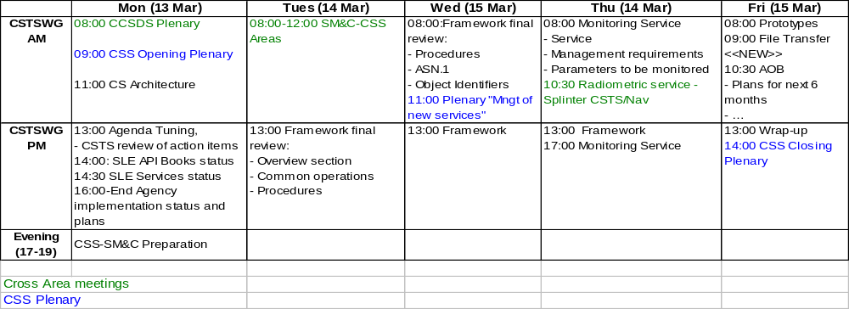
Table Of Contents
1 Review of Actions 7
2 SLE 7
2.1 SLE ISP (CCSDS 913.1-R-1) 7
2.1.1 On-Going Updates 7
2.1.2 Toolkit Impact on ISP 7
2.2 SLE API 7
2.2.1 SLE API Core Specifications (CCSDS 914.0-M.0) 7
2.3 SLE Services 8
2.3.1 CLTU: 8
2.3.2 RCF: 9
2.4 SLE Implementation Status 9
2.4.1 ESA 9
2.4.2 CNES 10
2.4.3 DLR 10
2.4.4 NASA 11
2.4.5 Cross-Support Summary Table 11
3 Toolkit 12
3.1 Framework (CCSDS 921.1-R-n) 12
3.1.1 General 12
3.1.2 Association Control 12
3.1.3 Information Query Procedure 12
3.1.4 Cyclic Report 12
3.1.5 Unbuffered Data Delivery Procedure 12
3.1.6 Buffered Data Delivery Procedure 12
3.1.7 Notification procedure 13
3.1.8 Throw-Event procedure 13
3.1.9 Data Processing procedure 13
3.2 Concept (CCSDS 920.0-G-n) 13
3.3 Guidelines (CCSDS 921.2-R-n) 13
4 Services 13
4.1 Monitored Data Cross Support Transfer Service (CCSDS 922.1-R-n) 13
4.1.1 Parameters 13
4.1.2 Functionalities 13
4.1.3 Naming 14
4.1.4 Number of instances (see 5.1): 14
4.2 Streaming Tracking Data Service (CCSDS 922.2-R-n) 14
4.3 Return Unframed Telemetry 14
5 Guidelines 15
5.1 Number of Procedure Instances 15
6 Prototype 15
6.1 Open items to be agreed during the prototype implementation 15
6.2 Framework 15
6.3 Monitoring 16
7 File Transfer 16
8 AOB 17
8.1 Items to be discussed in CSS Area 17
8.2 AOS based on CLTU 17
9 CSS – MOIMS 18
10 Annex A: SLE Implementation Report 19
10.1 NASA 19
10.2 DLR 20
11 Monitoring Service – John Pietras Presentation 22

Review of Actions
See actions above.

SLE

SLE ISP (CCSDS 913.1-R-1)

On-Going Updates
Figure 3-2: ASN.1 Type for the Credentials Parameter
ISP1Credentials ::= SEQUENCE
{ time OCTET STRING (SIZE (8)) -- CCSDS CDS time code
, randomNumber INTEGER (0 .. 2147483648)
, theProtected OCTET STRING (SIZE (20))
}
Should be changed to:
ISP1Credentials ::= SEQUENCE
{ time OCTET STRING (SIZE (8)) -- CCSDS CDS time code
, randomNumber INTEGER (0 .. 2147483647)
, theProtected OCTET STRING (SIZE (20))
}
A#01-1008 - Y.Doat to contact Secretariat for a late change in:
- ISP-1: The random number maximum authorized value is (2^ 31)-1.
- SLE API Core: same as for ISP (See below).

Toolkit Impact on ISP
The ISP is in charge of ASN.1 encoding:
- The Framework specifies ASN.1 extension as comments linking the extensions to the extended parameters. The impact on ISP is not clear:
a. Do we have to foresee an update of the ISP?
b. Is the ASN.1 extension clear enough?
- The services defined on the Framework have to specify the extensions. It is not clear at this stage if the ISP specifications need to be updated so that it knows what to do with Service extensions.
A#03-1008 – M.Goetzelman to look into the impact of the extension approach on the ISP.

SLE API

SLE API Core Specifications (CCSDS 914.0-M.0)
The following requirement needs to be changed from:
3.5.6.4.2 The ASN.1 type used for encoding shall be defined as
HashInput ::= SEQUENCE
{ time OCTET STRING (SIZE(8))
, randomNumber INTEGER (0 .. 2147483648)
, userName VisibleString
, passWord OCTET STRING
}
To: “The ASN.1 type used for encoding shall be defined as
HashInput ::= SEQUENCE
{ time OCTET STRING (SIZE(8))
, randomNumber INTEGER (0 .. 2147483647)
, userName VisibleString
, passWord OCTET STRING
}”

SLE Services
2008.10.17: The updated books are ready for publication..
W.Hell reported:
- Inputs provided by J.Pietras during Summer 2008 have been included;
- The updates discussed in Washington are in progress.

JPL (Ed.Greenberg) prepared an Orange book (experimental) for AOS over CLTU.

Due to the late development of Service Management, Agencies developed a private Service Instance implementation making use of permanent Service Instance.
The differences between permanent SI compared to a scheduled SI configuration are:
- Service identifier;
- Service provision period.

As part of the Service Package, Service Management supports a SI profile with a fixed service instance number, but not a fixed pass number and not a fixed service provision period.

From a discussion with J.Pietras, it seems the description of SI in the SLE books and SM definition for the Service Package is not fully consistent. A detailed review is required.
A#07-1008, M.di Giulio to compare the Service Instance definition in the SLE books and in the SM book.

Punctured code – timing.
The books have been prepared with a text which is not in line with the coding group. The Coding group will make a RID with a proposed new text.

CLTU:
Email exchanged (J.Pietras and W.Hell 08.07.2008) showed that the following parameters should be gettable:
- acquisition-sequence-length
- minimum-delay-time
- notification-mode
- plop-1-idle-sequence-length
- protocol-abort-mode

The changes would improve the comprehensiveness of the service. A need to clean-up the list may be identified with additional parameters required to be in-line with Service Management.
Decision: The new parameters will not be included in the new version of the books.

A#02-1008 – J.Pietras to review the list of parameters in the SM book to make sure that the SM book is in line with what is listed in the existing SLE Books (Table 3-1).

RCF:
JPL requested, during the last ESA-JPL Technical Interchange Meeting (TIM), a change to RCF to allow selection of multiple channels in the START request. This feature is mainly required in the context of AOS which makes use of numerous channels.
Impact on the books:
- Change in the specification of the START and associated behavior;
- ASN.1 change.
Positions:
- ESA; this feature is not required.
- CNES: this feature is not required.
- ISS: the data rates are low enough and no needs was identified (input from John Pietras)
- DLR: this feature is not required.
- Goddard: this feature is very desirable
Impact on the systems:
- Support on-line delivery of the selected channels;
- Support off-line delivery of the selected channels.
ESA reported that as the storage is organized on a per channel basis, the retrieval implies a re-construct of the TM.
CNES reported that the storage is organized for all frames and the extraction of several channels would not be a major modification.

The books are ready for publication without this feature increased. The books will be published as they are. In case such a facility is strongly required by an Agency, that Agency should raise a formal RID to the book during the review.

SLE Implementation Status

ESA
User:
F-CLTU, FSP, RAF, RCF, R-OCF: native implementation in the ESA Ground-Station systems.

Provider:
F-CLTU, FSP, RAF, RCF, R-OCF: implementation available.

The SLE approach is used as baseline for all ESA internal missions and has been demonstrated on several cross-support missions.
The versions 1 (Red) and 2 (Blue) are available as user and provider.
ESA is prepared to implement and deploy the version 3 of the books (Blue) as soon as available. The changes identified today in the version 3 (Blue) mainly impacts the SLE API and not the application.

ESA developed and maintain the SLE API (user and provider).

CNES
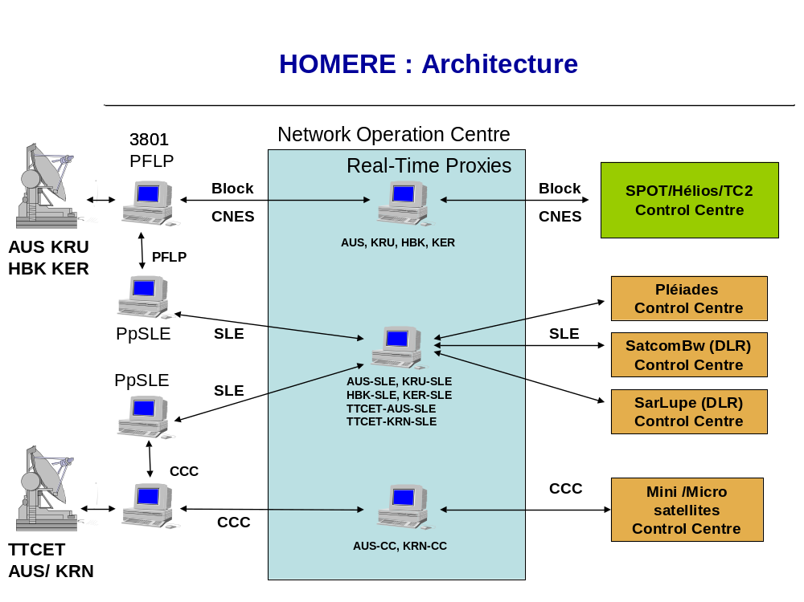
CNES support: F-CLTU, RAF, RCF, R-OCF as user and provider.
5 stations: Aussagel (AUS), Kourou (KRU), Hartebeestuck HBK), Kergelen (KER). The validation is on-going
The implementation is based on gateways installed in the ground-stations. The gateways are based on ESA SLE API

CNES internal missions are now SLE based.

Support to DLR (CNES is provider): SarLupe SatcomBw

DLR
See presentation: 10.2

DLR support F-CLTU, RAF, RCF as user and provider.

DLR make use of 3 DLR Stations, 1 CSAT, 1 SSC and KSAT stations.

SLE is implemented at the stations based on a DLR gateway.

NASA
See presentation: 10.1
NASA support F-CLTU, RAF, RCF as user and provider.
The intention is to deploy the SLE services as institutional services as part of the NAS wide SCaN network.

NASA is considering using the F-CLTU for AOS forward link. Ed.Greenberg prepared an Orange Book (experimental).

Cross-Support Summary Table
Yellow background: Future missions
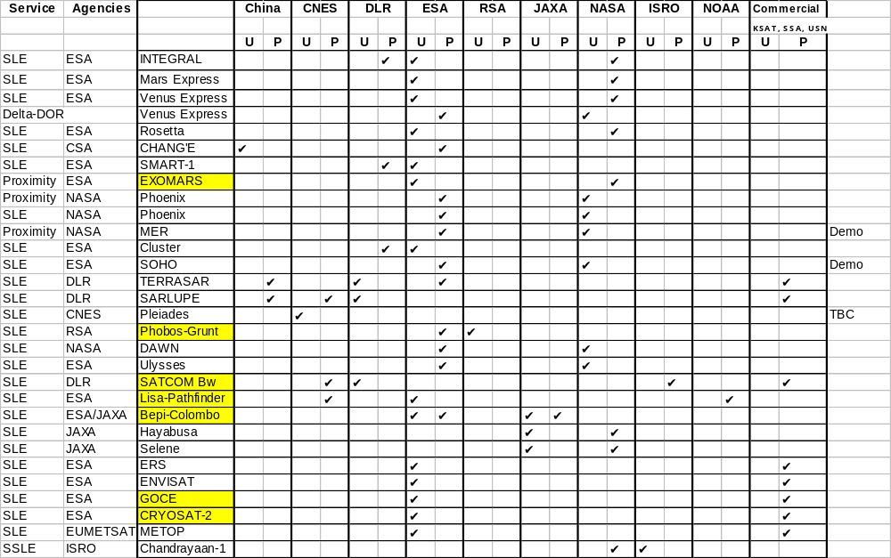

Toolkit
The document was updated during the meeting and the version 0.16 delivered to all participants.
Additional comments will be provided by Martin Goetzelmann and Wolfgang Hell by 22.11.2008.

Framework (CCSDS 921.1-R-n)
Input: draft 0.15.
The impact in ISP was addressed: see 2.1.2 Toolkit Impact on ISP

During the discussion and reviewing the ASN.1 it became clear to everybody that the Buffered Data Delivery and Unbuffered Data delivery procedures cannot be used directly. These procedures need to be derived for defining the data carried by the TRANSFER-DATA operation. The minimum definition will be to specify the Transfer Syntax (ASN.1 Object Identifier) used for the data.

The Transfer Syntax used for any extension should identify the extension type of data and the extension syntax, e.g. iso.3.112.4.3.2.3.18.2.12 could identify TM data as structured in frame format (The number in the example is incorrect, so don’t try to match it to what it should be).

General
Each procedure shall have a version number that the service shall refer to.
Considering that the procedures in the framework are coupled to the operations in the same books, it is not necessary to have versioning at the level of the operations.

Association Control
Detailed review.

Information Query Procedure
Detailed review.

Cyclic Report
Detailed review.

Unbuffered Data Delivery Procedure
Detailed review.

Buffered Data Delivery Procedure
The procedure makes the difference between service provision and production in the context of the recorded buffer. It was agreed to limit the references to Service Provider to avoid statement the could be understood as implementation statements.

Notification procedure
Extension is required to ensure that the procedure can be used as is without derivation (i.e. generic Notification), so that new events can be considered without having to derive a new procedure (for new values) and subsequently change the service recommendation.

Throw-Event procedure
Extension is required to ensure that the procedure can be used as is without derivation, so that missions can add their own values without having to derive a new procedure (for new values) and subsequently change the service recommendation.

Data Processing procedure
Detailed review.

Concept (CCSDS 920.0-G-n)
Not reviewed.

Guidelines (CCSDS 921.2-R-n)
Not reviewed.

Services

Monitored Data Cross Support Transfer Service (CCSDS 922.1-R-n)
Presentation from J.Pietras: see 11.

The Monitoring Service is now called “Monitored Data CSTS”.

The book refers to the version numbers of the procedures. The Framework has been updated to include the version number for each procedure.

The structure of the book was reviewed.

Parameters
ESA started to work on a combined list (ESA, JPL, DLR).
A#05-1008, W.Hell to review the ESA combined parameters list and distribute it to CSTS.
A#06-1008, F.Lassere to approach CNES missions to identify the CNES needs.

Functionalities
The identified capabilities are:
- Cyclic delivery using the Cyclic Report procedure
- On-request using the Information Query procedure (optional as agreed in Washington)
- On-event using the Notification procedure (optional as agreed in teleconference 200805)

Several participants mentioned the possibility to have additional capabilities:
  - On-change capability;
  - Off-line retrieval capability.

During the 200805 teleconference, off-line retrieval capability was addressed but was felt to be over-complex for the needs. An action was raised (A#01-0508, All Agencies to review the requirements for monitoring services discussing the matter for SLE-type service or simple service) to all Agencies but the action was not copied in the list of actions and was overlooked.

All participants agreed to:
- Finalise the Monitoring Service with the current agreed functionality (Cyclic, Query and Notification). In case additional functionality would be required they would be inserted as extension to the Monitoring Service or as a new derived service.
- Start to discuss the parameters to be monitored.

Naming
Structure:
- Distinguished Names seems a suitable structured approach;
- The Distinguished Name should be attached to an alias for operator representation;
- The Distinguished Name should be agreed form the structure of a general dictionary for the area and possibly to be later extended at CCSDS level.
Each parameter shall identify:
- Its name;
- Its semantic;
- Single or multiple values (A#04-1008 – Y.Doat to look into the reason to keep the multiple types-values capability for a parameter);
- Its type;
- Its range.

Number of instances (see 5.1):
- Association: 1..1
- Information Query: 0..1
- Cyclic Report: 1..n
- Notification: 0..1

Streaming Tracking Data Service (CCSDS 922.2-R-n)
Splinter meeting with Navigation.

Return Unframed Telemetry
Not reviewed.

Guidelines

Number of Procedure Instances
The number of required instances will be specified as <min value>..<max value>. A compliant implementation shall support a minimum of <min value> instance and a maximum of <max value> instances
e.g.:
- ‘1 .. n’: The provider has to support at least 1 instance;
- ‘1 .. 10’: The provider has to support at least 1 instance and no more than 10. 1 instance only would be compliant;
- ‘1..1’: The provider has to support one and only one instance.

Apart from above item, the Guidelines were not reviewed.

Prototype
The prototypes will be based
- ISP using ASN.1 BER;
- Authentication limited to BIND and as in SLE;
- All times to be used: UTC.

John Pietras reminded that to go from Red to Blue two independent implementations shall demonstrate the entire capability.
ESA reported that the full implementation to go Blue may be constraint by budget availability most probably by end 2010.
Goddard cannot confirm at this stage that Goddard would go for the full implementation.

Open items to be agreed during the prototype implementation
- Framework: ASCII File format to be agreed;
- Monitoring: parameters to be agreed;
- Service agreement: Service Instance configuration.

Framework
ESA is starting the Framework prototype Request for Quotation.
Analysis of the existing SLE API and possible reuse.
Procedures considered:
- Association
- Buffered Data Delivery implementing the real-time capability.
Functionality:
- Transfer of ASCII data read from a file. The format is to be agreed

ESA will implement the provider side.
Goddard will implement the user side.

Plans:
- ESA prototype should be ready by end of June 2009.
- Goddard prototype should be ready sometimes in 1st quarter 2009

Monitoring
Procedures considered:
- Unbuffered Data Delivery
- Cyclic Report
The list of parameters is to be agreed

CNES will implement the provider side.
Goddard will implement the user side.

Plans:
- CNES prototype could be ready by end 2009.
- Goddard prototype could be ready by end of June 2009.

File Transfer
“Guidelines for interagency routine file transfer service (best practices recommendation)”

File exchanges are performed today on a bilateral agreement and Agencies identified a need for an harmonization of the file exchange process.

CSA will address the file service and its attributes to be included in the service catalogue.

Coverage:
- File naming;
- File routing;
- File transfer protocol;
- Compression;
- Network topology (servers location outside or inside firewalls);
- Security.

Assumptions:
- The activity would first review the existing practices and base the book on them.
- The borderlines are cross-support between Agencies (ground-stations < -- > Control centers, Control centers < -- > control centers, others?).

To implement the book:
- Analysis of existing practices in various Agencies and compile a catalogue.
- Book edition
- WG to review
- Agencies to review

In view of the current workload in the working group, this activity could only start end 2009, once the current books (Framework, concept, guidelines, monitoring service) will be out for review.

AOB

Items to be discussed in CSS Area
Prototypes:
- To go Blue? Implementation full functionality? with or without all possible options?
- Guidelines will be Blue book. Prototypes cannot be implemented as the Guidelines will prescribe the way a service is to be built.
- AOS based on CLTU: NASA will work on an experimental approach (CCSDS Orange book). CSTS consider the approach technically interesting.
- Need for a dictionary.
- SLE Books ready for publication. CSS area resolution required.
- File transfer: activity start by end 2009 (or spring 2010).

AOS based on CLTU
Presentation from Ed.Greenberg.
Informally, Ed gave a copy of the marked F-CLTU item.
The approach is not in the CSTS Charter. If required, NASA should work on the experimental approach.
In a medium term, if Agencies are interested, a new service AOS-uplink CSTS should be developed (i.e. using the Framework).
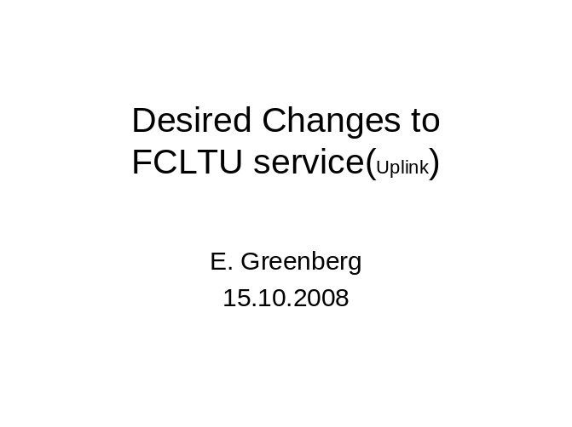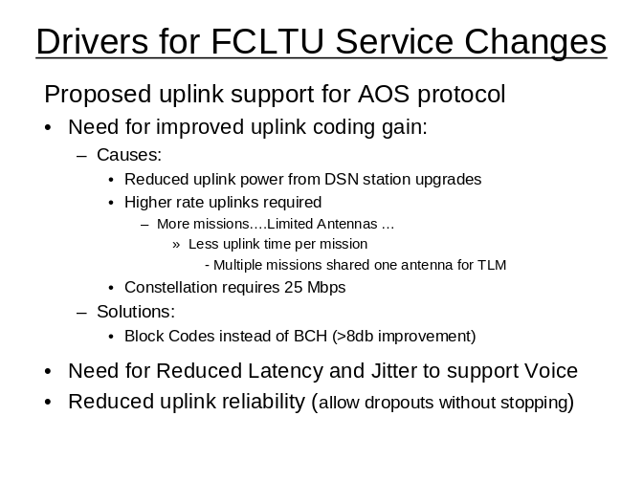
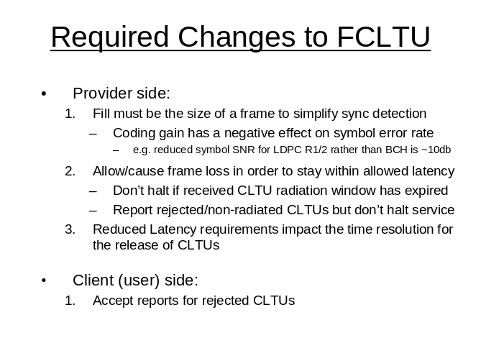
Ed.Greenberg showed the minor anticipated changes on the CLTU book.
Considering that the CSTS charter does not cover the reported activity, the Working Group will report the work to CESG.

CSS – MOIMS
Issues addressed:
- UML representation required but not well accepted by the reviewing community;
- MOIMS use UML and XML Schema
SM use UML and XML Schema
CSTS use text description and ASN.1;
- MOIMS Interaction Pattern = CSTS Procedures
- MOIMS Consumer-Provider / CSTS User-Provider
- One phase operations supported in MOINS and CSTS but terminology is different;
- Two phases operations supported in MOIMS and CSTS but terminology is different;
- MOIMS support multi-return operations. CSTS support three phases operations, intermediate progress may be reported by use of NOTIFY.
- MOIMS support multi-provider, multi-consumer data broadcast not required in CSTS.

Harmonization with CSTS seems difficult at this stage as CSTS is nearly ready to publish the Framework.

Annex A: SLE Implementation Report

NASA
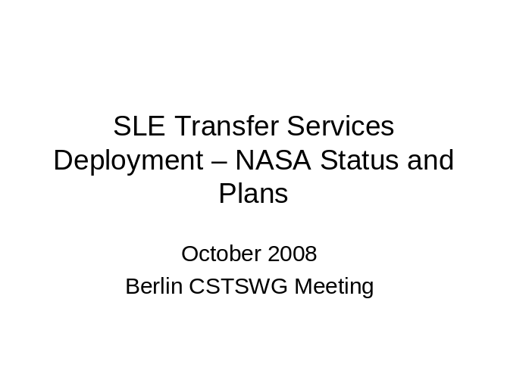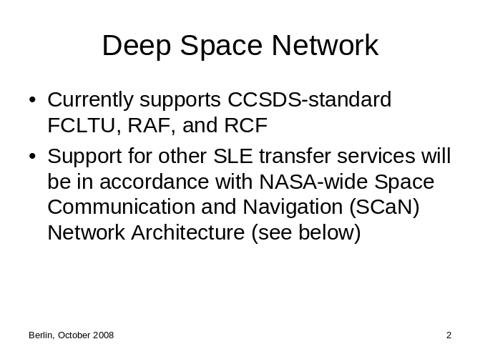
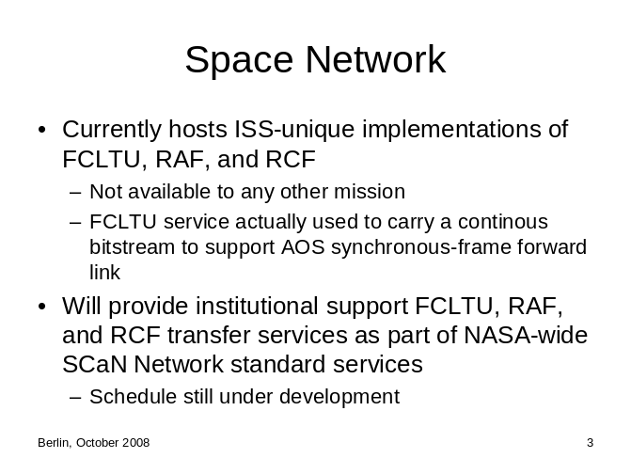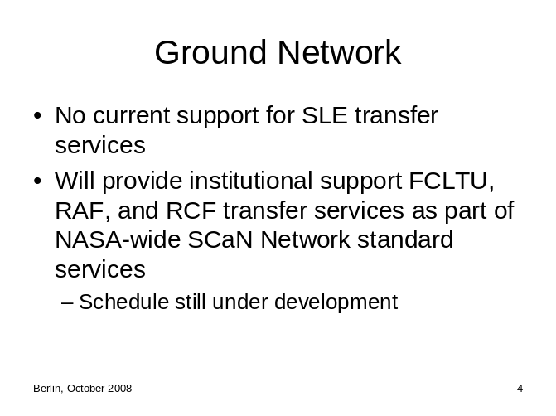
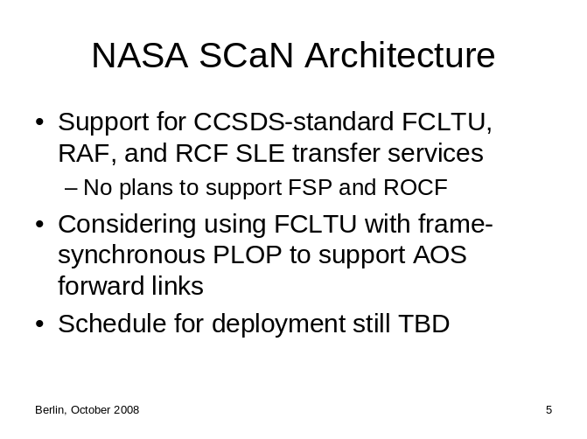

DLR
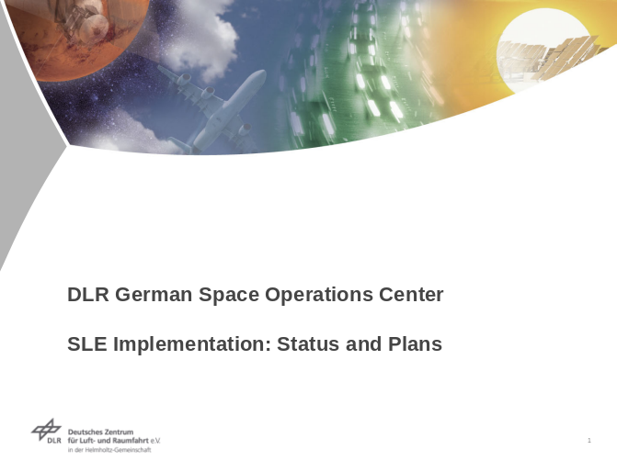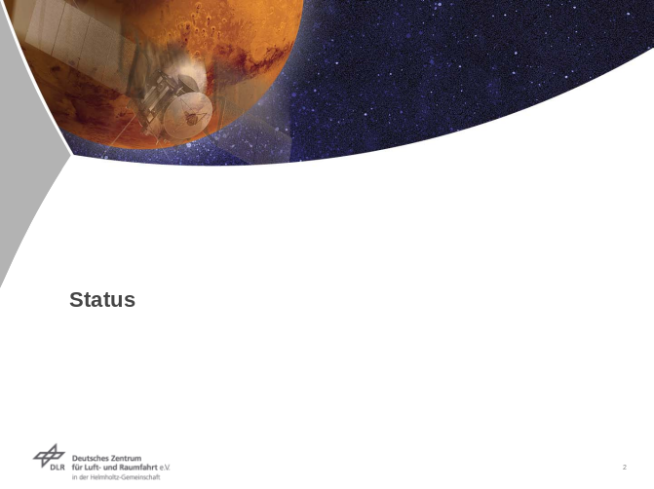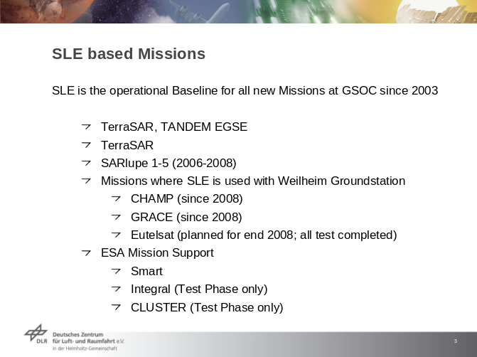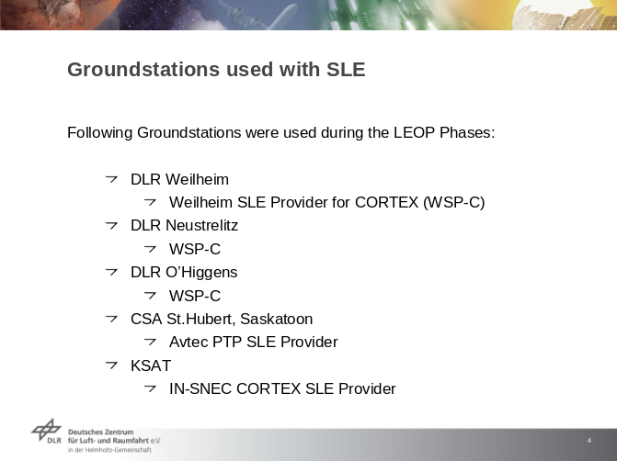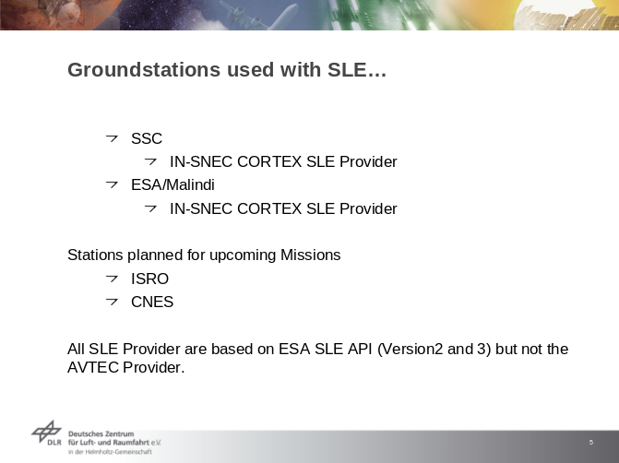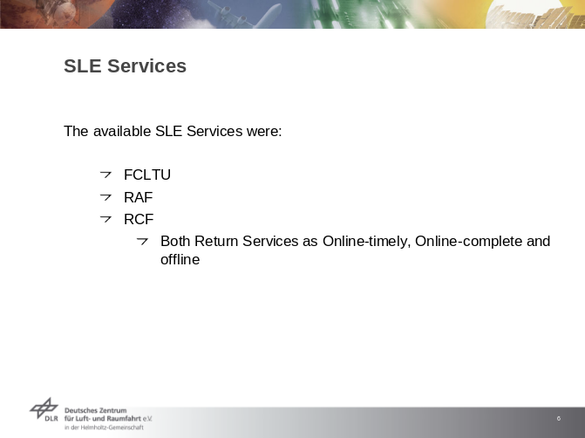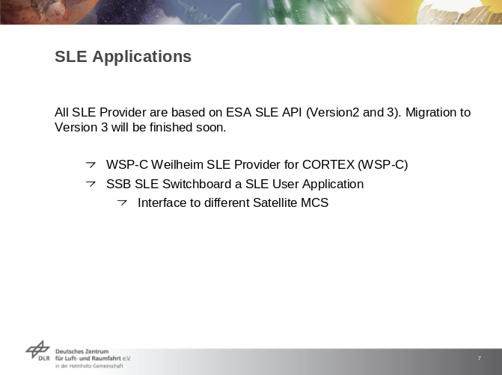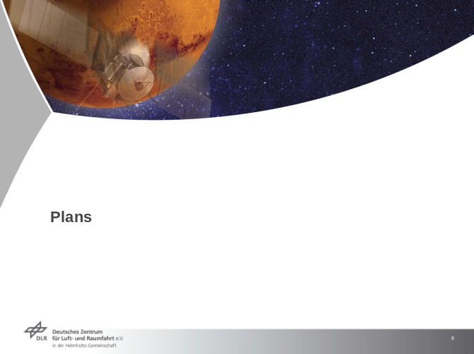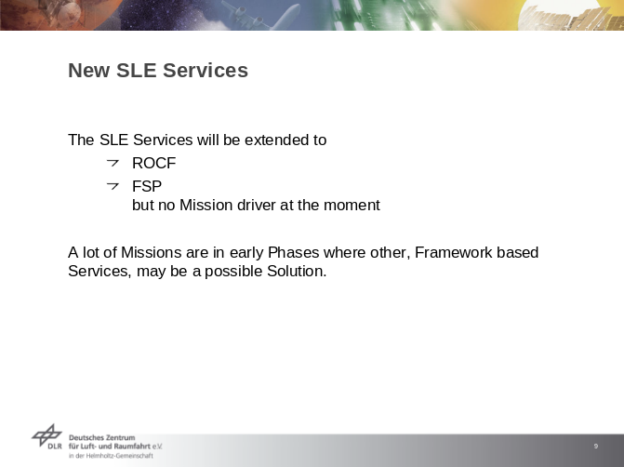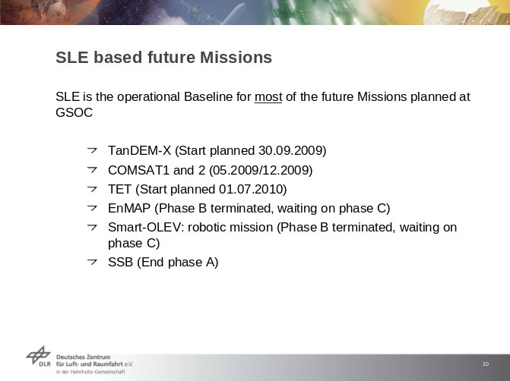

Monitoring Service – John Pietras Presentation


