
Concept Paper Concerning Space Data System Standards
MO Mission Planning Services
Draft CONCEPT PAPER
CCSDS 000.0-X-0
Draft WHITE PAPER
September 2012

CONTENTS

CONTENTS ii
1 Introduction 1
1.1 PURPOSE 1
1.2 SCOPE 1
1.3 References 2
1.4 List of Acronyms 3
2 Background 4
3 Overview of CCSDS Mission Operations Service Concept 6
4 Potential Scope and Benefits of MO Mission Planning Services 9
4.1 Benefits of Standardizing MO Mission Planning Services 9
4.2 Scope of Mission Planning Services 10
5 Identification of Potential MO Mission Planning Services 12
5.1 Mission Planning Scenarios 12
5.2 Communicating Entities and Functions 13
5.3 Potential Services and Exclusions 15
5.4 MO Service Definition 16
5.5 Existing Standards and other Inputs to Standardization 17
6 Case Study: Venus Express 18
6.1 Overview 18
6.1.1 What Not to Standardise 19
6.1.2 What to Standardise 19
6.1.3 Proposal for Generic Planning Services 22
7 Conclusions 24

Introduction

PURPOSE
This document is a Concept Paper for the Consultative Committee for Space Data Systems (CCSDS). CCSDS Concept Papers are working documents of the CCSDS, its Areas, and its Working Groups. Concept Papers have no official status, and are simply the vehicle by which technical suggestions are made visible to the CCSDS. They are valid for a maximum of nine months and may be updated, replaced, or rendered obsolete by other documents at any time.
This Concept Paper is intended for consideration by the CCSDS Mission Operations and Information Management Area (MOIMS) as a brief statement of the technical scope of proposed Mission Operations Services for Mission Planning.

SCOPE
The CCSDS Spacecraft Monitoring & Control Working Group is developing standardised Mission Operations (MO) Services that enable interoperable information exchange between collaborating agencies or organisations involved in the operations of space missions. This approach uses service-oriented concepts and focuses on meaningful (semantic level) information exchange.
Standards already in place define a Reference Model; a Message Abstraction Layer (MAL); and a Common Object Model that provides a template for a generic service. The MAL isolates services from deployment technology and may be "bound" to multiple message transport and encoding technologies - including both terrestrial technologies and space communications protocols.
Each MO service defines the Information Model for a specific type of information, together with the operations that can be performed on this. Currently, only basic M&C services have been specified, but future services have been identified to support the exchange of Mission Planning information. For the last CCSDS technical workshop, a Call for Interest was issued for the development of such Mission Planning service specifications.
This paper presents an initial “straw man” concept for such services, identifying the types of information exchange that could potentially be supported and considering some of the key requirements and challenges that any such standardisation effort will need to address.

References
The following documents are referenced in this Report. At the time of publication, the editions indicated were valid. All documents are subject to revision, and users of this Report are encouraged to investigate the possibility of applying the most recent editions of the documents indicated below. The CCSDS Secretariat maintains a register of currently valid CCSDS documents.
[1] Mission Operations Services Concept, Informational Report (Green Book), CCSDS 520.0-G-3, December 2010,
http://public.ccsds.org/publications/archive/520x0g3.pdf
[2] Mission Operations Reference Model, Recommended Practice (Magenta Book), CCSDS 520.1-M-1, July 2010,
http://public.ccsds.org/publications/archive/520x1m1.pdf
[3] Mission Operations Message Abstraction Layer, Recommended Standard (Blue Book), CCSDS 521.0-B-1, September 2010,
http://public.ccsds.org/publications/archive/521x0b1.pdf
[4] Mission Operations Common Object Model, Draft Recommended Standard (Red Book), CCSDS 522.0-R-2, September 2011,
http://public.ccsds.org/sites/cwe/rids/Lists/CCSDS%205220R2/Attachments/522x0r2.pdf
[5] Space Communication Cross Support - Service Management – Service Specification, Recommended Standard (Blue Book), CCSDS 910.11-B-1, August 2009,
http://public.ccsds.org/publications/archive/910x11b1ec2.pdf
[6] OpenGIS Sensor Planning Service, EO Satellite Tasking Extension, OGC, 10-135, March 2011, http://www.opengeospatial.org/standards/sps
[7] Kovacs D. L. BNF Definition of PDDL3.1: completely corrected, without comments, Unpublished manuscript from the IPC-2011 website, 2011,
http://www.plg.inf.uc3m.es/ipc2011-deterministic/Resources?action=AttachFile&do=view&target=kovacs-pddl-3.1-2011.pdf

List of Acronyms

API | Application Programming Interface
CCSDS | Consultative Committee for Space Data Systems
COM | [CCSDS MO] Common Object Model
GIS | Geographic Information System
ISO | International Organization for Standardization
M&C | Monitoring and Control
MAL | [CCSDS MO] Message Abstraction Layer
MO[S] | [CCSDS] Mission Operations [Services]
NAV | [CCSDS MO] Navigation Services
OGC | Open Geospatial Consortium
PDDL | Planning Domain Definition Language
PI | Principal Investigator
PLN | [CCSDS MO] Mission Planning Services
SLE | [CCSDS] Space Link Extension Standards
SOC | Spacecraft (or Science) Operations Centre
TM/TC | Telemetry / Telecommand

Background

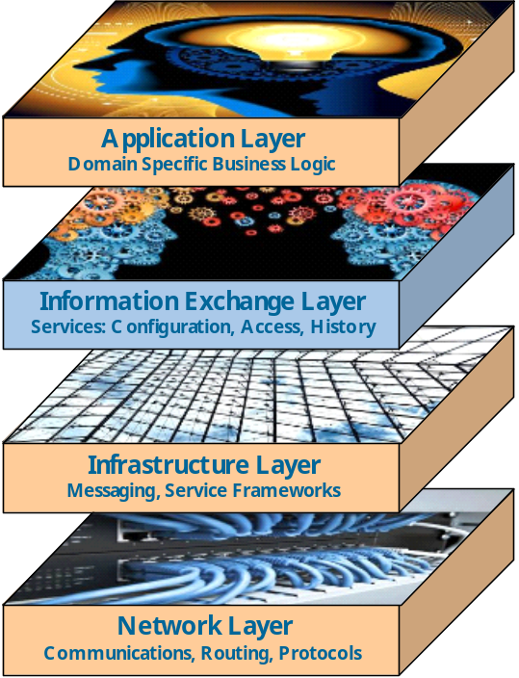
Figure 1. The CCSDS MO Service Layer
MO Services provide an information exchange layer between mission operations applications and the infrastructure technologies used to integrate them, supporting meaningful Information Exchange between applications.
The Consultative Committee for Space Data Systems (CCSDS) is an international standards organisation affiliated to the International Organisation for Standardisation (ISO). Its Spacecraft Monitoring & Control Working Group is developing a set of standardised Mission Operations (MO) Services that enable interoperable information exchange between collaborating agencies or organisations involved in the operations of space missions. The approach uses service-oriented concepts and focuses on meaningful (semantic level), end-to-end information exchange between software applications supporting mission operations functions. These applications may be distributed between organisations and also between a range of space and ground-based systems. The resultant MO Services will support both live information exchange and open access to operations history.
The focus of the working group to date has been in the definition of an extensible framework for the definition of such services that is independent of technology used to deploy the services. This allows for the evolution of implementation technology during the long lifetime of many space systems and also for the diversity of transport protocols that may be required to support communication in different environments.
The CCSDS Mission Operations Services Concept¹ identifies a range of application level services, including several that are relevant to the Mission Planning function:
- Planning Request
- Scheduling
- Navigation
To date only the Monitoring & Control service has been developed. As part of the CCSDS Technical Meeting held in Darmstadt, Germany in April 2012, a call for interest was issued to members of the Mission Planning community to initiate the process of service standardisation relevant to Space Mission Planning. A dedicated session on the topic was attended by 58 specialists, mostly from Europe. A similar session is now planned for the next CCSDS Technical Meeting in Cleveland, Ohio later this year. Providing sufficient support is obtained from member agencies, the formal process of standardisation within CCSDS will then be initiated.
This paper provides background on the CCSDS Mission Operations Services and the potential scope and benefits of MO Mission Planning services, before proposing an initial concept for such services, incorporating initial feedback obtained during the session in Darmstadt.

Overview of CCSDS Mission Operations Service Concept
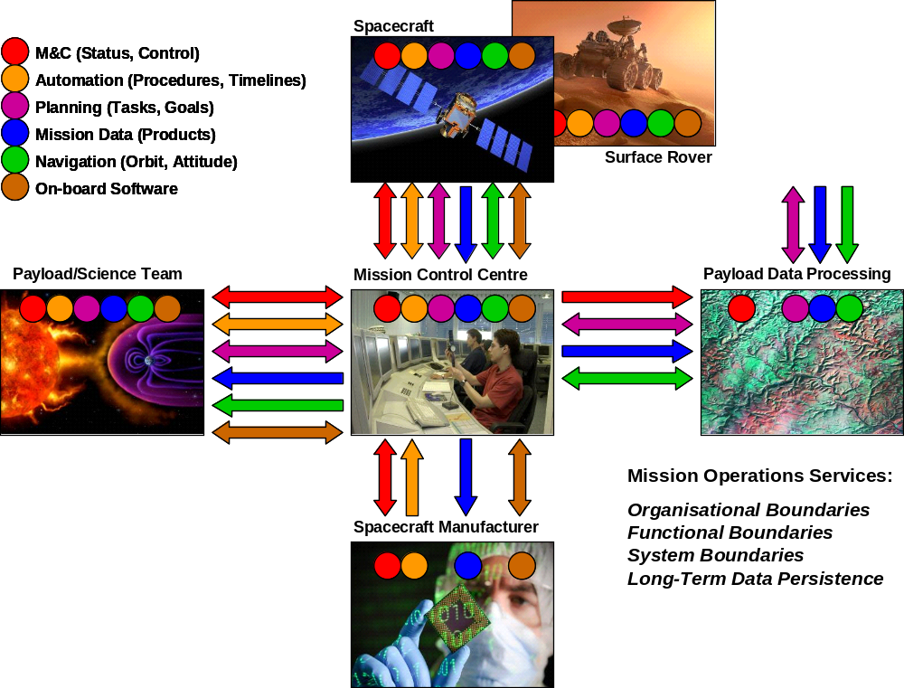
Figure 2. Distributable Mission Operations Functions.
Distribution of functions exposes potential MO services at interoperable boundaries between organizations/entities and systems, increasingly including the space segment itself.
Mission operations functions are increasingly distributed more widely than a central Mission Control Centre (Fig. 2). There may be separate Payload Operations Centres, Payload Data Processing Centres, as well as Principal Investigator (PI) teams and end users. The spacecraft and payload manufacturers may play a continuing role from initial development into mission operations; and the increasing capability of on-board computers allows the migration of intelligence from ground to space-based systems. This distribution of functions often crosses organisational boundaries, due to the collaborative nature of space missions and requires interoperability between agencies. It can also highlight the boundaries between functions and systems within an organisation where intra-operability between major system components is desirable to enable re-use and rapid integration of mission systems.
The CCSDS MO Services Concept introduced previously seeks to establish an extensible set of standard Mission Operations services to support inter- and intra-operability between applications at organizational, functional and system boundaries.
Standards already developed include a Reference Model²; a Message Abstraction Layer (MAL)³; and a Common Object Model (COM)⁴. Application level MO Services are defined in terms of the MAL and COM for specific types of mission operations information exchange. This layered framework for service specification is illustrated in Fig. 3.
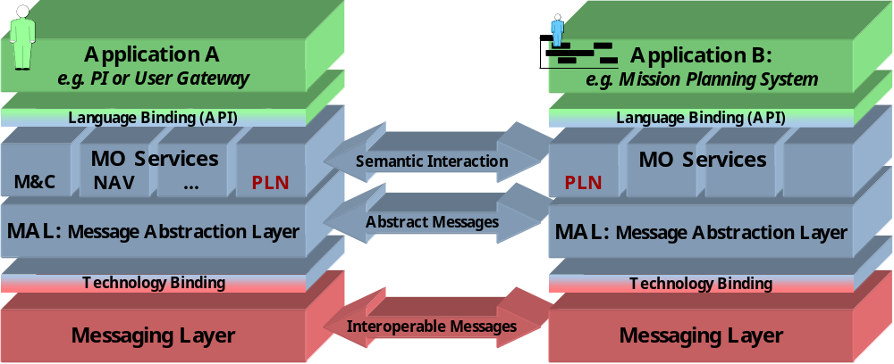
Figure 3. Layered MO Service Framework.
MO Services support semantic level interaction between mission operations applications. These are defined in terms of the Message Abstraction Layer that can be deployed over different messaging technologies. To allow deployed applications to interoperate, a common binding must be used.
The MO Services themselves support meaningful message exchange between applications, independent of programming language or underlying message encoding and transport. An extensible set of MO Services can be defined, each based on a shared model for a particular class of information exchanged, together with the set of operations that the service consumer can invoke.
The COM provides a generic template for an MO service and the object classes it defines simplify the specification of individual MO services and ensure a harmonised approach across multiple services.
The MAL defines an abstract message structure and a set of standard interaction patterns for message exchange, including both request-response and publish-subscribe patterns. The MAL isolates services from deployment technology and may be "bound" to multiple message transport and encoding technologies - including both terrestrial technologies and space communications protocols. Two types of MAL binding exist:
- Language Bindings define how to express the API for a service in a particular programming language. This defines a transformation rather than a specific service API and therefore defines the API for all services specified in terms of the MAL. Communicating applications can be implemented in different languages and use different Language Bindings, but still interoperate as the underlying communication is defined in terms of the MAL.
- Technology Bindings define how the MAL messages and interaction patterns are implemented for a specific messaging technology. A common technology binding must be used to enable interoperability between applications, but which technology is used in deployment is transparent to the application layer and can be specific to deployment requirements. Bridging between technologies is also possible at the MAL layer. Standardisation of technology bindings allows for interoperability between independently developed systems, but private bindings can also be developed for intra-operability between applications within a single system context. All MO Services can be migrated to a different deployment technology through the definition or adoption of an alternative MAL technology binding.

Potential Scope and Benefits of MO Mission Planning Services

Benefits of Standardizing MO Mission Planning Services
The specification of standardized interoperable interfaces between PIs, Users, Operating Agencies and Spacecraft would in itself bring a number of benefits. Each organization would be able to develop or integrate their own multi-mission systems that can then be rapidly integrated via the common service layer with other systems as required to support a particular mission. It does not preclude the re-use of legacy systems, but only one adaptation layer is required to support all missions, rather than many mission-specific bespoke interfaces.
The development of a standard will require the alignment and agreement of common concepts across multiple missions and mission classes. This does not imply a “one size fits all” approach – separate standards or optional elements within standards may be required to support different concepts – but where commonality exists, alignment of concepts and terminology will simplify integration. Standards would need to recognize different approaches to mission planning, including:
- Task, Constraint or Goal-based algorithms
- Time, Position or Event-based Plans and Schedules
- Discrete, Multi-part and Repetitive Operations
Many current mission planning interfaces are supported by exchanging files of agreed format, sometimes with a many file formats being used within a single mission system, with different formats being used to exchange similar data across different interfaces. Simple agreement on common, standard file formats would bring benefits in itself, but has limitations:
- It assumes file transfer as the exchange protocol
- It only defines the static aspects of information exchange (the data structure) and not the dynamic interaction protocol required to initiate an exchange or provide feedback on status. This is currently often achieved through ad-hoc operational mechanisms, including phone calls and person-to-person e-mail exchanges.
MO Planning Services would define both the static information exchanged and the dynamic interaction protocol for those exchanges, as a set of standard operations that include provision of status feedback to the initiator. Multiple messaging technologies can be supported based on the same service specification: file exchange can be supported, but so can other technologies, such as e-mail, enterprise service buses or packet TM/TC links. It is also an enabler for the recording of service history.
Despite these benefits, the question has been raised as to whether there is a net cost benefit. The cost of developing standards has to be set against cost savings in deployment and operations of mission systems, which are difficult to predict. However, an advantage of developing MO Planning Services is that the cost of standards development is minimized by building on the existing MO Service framework.

Scope of Mission Planning Services

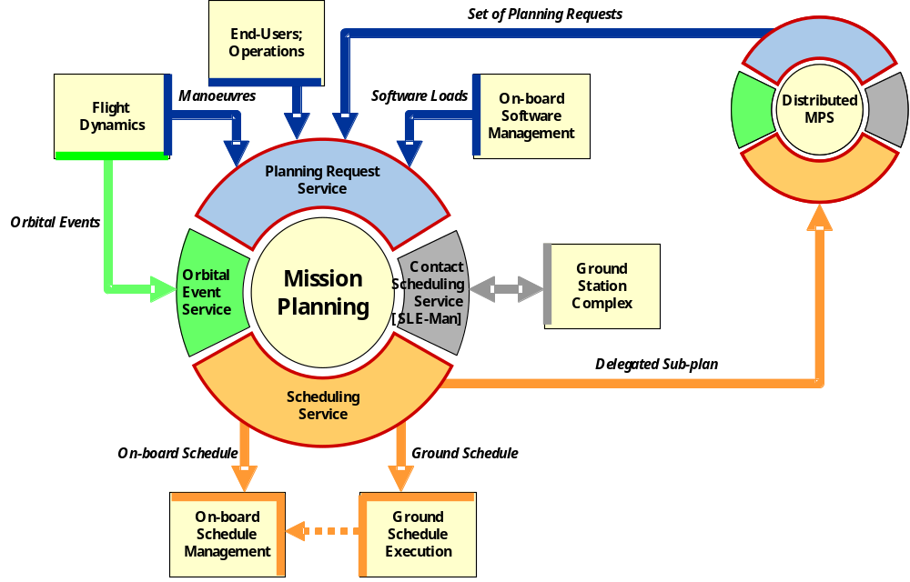
Figure 4. Potential MO Mission Planning Services Scope.
Mission planning is loosely coupled to other functions via a set of standard services. These services support both planning inputs and outputs and can also be used to integrate distributed mission planning functions.
Figure 4 illustrates the anticipated context of MO Mission Planning services as envisaged by the MO Services Concept¹. This is an initial perspective that is subject to revision in the course of any future standardization program.
The scope of MO Services is to standardize the exposed interfaces between applications and not to standardize the applications themselves. The objective is to enable integration of a range of different Mission Planning solutions and algorithms into the wider mission operations system. This allows for re-use across missions, evolutionary change and innovation.
The Mission Planning function is shown surrounded by a set of services that support loosely-coupled interaction with other systems.
Mission Planning System interfaces include: the submission of planning requests from end users and members of the operations team that correspond to operations to be performed or goals to be achieved (shown as a Planning Request service in blue); the receipt of orbit vectors or predicted events that may be needed to identify when such operations should be performed (Orbital Event service in green); interaction with network service providers to identify the availability of ground station and relay satellite resources and to negotiate allocation of these to support mission operations (Contact Scheduling service in grey) ; and the provision of plans or schedules to delegated operations execution functions located within the ground segment and/or on-board the spacecraft (Scheduling service in orange).
The Orbital Event service is anticipated as an MO Navigation service, and contact scheduling is already addressed by the CCSDS Cross-Support Services Service Management standard. MO Mission Planning standardization is therefore expected to focus on Planning Request (input) and Scheduling (output) services.
In the case that the Mission Planning function is itself distributed, then either the Planning Request or Scheduling services can be used to delegate responsibility for a sub-plan/schedule to another system.

Identification of Potential MO Mission Planning Services
This section outlines the approach taken during the workshop held at the CCSDS Technical Meeting in Darmstadt, April 2012 in response to the Call for Interest in MO Mission Planning services. The focus of this meeting was to engage the Mission Planning community in the proposed standardization process and identify candidate services for standardization. Following an introduction to the MO Services Concept by the working group, several short position papers were presented by Mission Planning specialists before a discussion forum was held structured around the following questions:
- Which mission planning scenarios should be considered?
- What are the communicating entities and functions involved in mission planning?
- Which candidate services can be identified – and what should be explicitly excluded?
- Has work already been done that can be used as a basis for standardisation in this area?
These issues are discussed below, together with a summary of what needs to be done to define an MO Service.

Mission Planning Scenarios
The distribution of mission planning functions and users for a given mission is dependent on a number of factors. Firstly there is the class of mission:
- Earth Observation missions: can be both systematic (little end-user interaction) and request-based (driven by end-user interaction).
- Observatory missions: similar to above
- Science/Exploration missions: can have complex constraints due to competing resource requirements of different instruments
- Communications and Navigation missions
- Surface Landers and Rovers: increasing levels of autonomy lead to on-board planning capability
- Manned Space missions
Secondly there is the structure of the ground-based mission operations organization:
- Single Mission Control Centre
- Distributed operational responsibility (e.g. Payload and Platform)
- Separate Payload Data Segment
Thirdly there is the degree of on-board autonomy:
- Limited: real-time operations driven from the ground (typical for Communications satellites)
- On-board schedule providing mission timeline capability
- On-board position-based scheduling: increasingly common for Earth Observation missions
- On-board autonomy: goal-based commanding or autonomous re-planning (e.g. on rovers)
It is clear that there are commonalities across multiple mission classes and an indication that it would be possible to derive a smaller set of mission criteria that impact mission planning. No full analysis has yet been performed, but potential criteria include:
- Whether the mission is systematic or request-driven
- Whether tasking is by time, position or event
- Whether the spacecraft requires pointing to satisfy individual requests
- Whether planning responsibility is distributed
- Whether the spacecraft can autonomously modify the plan/schedule

Communicating Entities and Functions
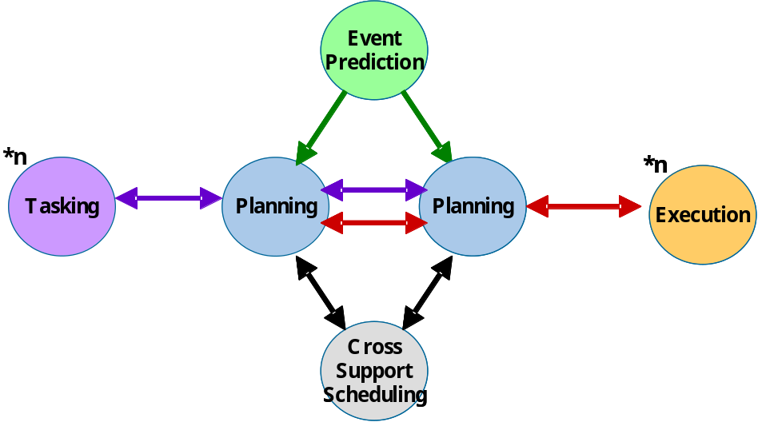
Figure 5. Functions Involved in (Distributed) Mission Planning.
Multiple functions can generate tasking requests as input into planning and planning can distribute plans/schedules to multiple ground-based or on-board execution environments. Predicted events are required by the planning process and interaction is also required with ground station scheduling.
A generalized view of the functions involved in Mission Planning and their interactions is given in Fig. 5. This is consistent with the view previously given in Fig. 4 and interactions are colour coded to indicate potential services. Two instances of the Planning function are shown to illustrate the scope for distributed Mission Planning.
These functions may be distributed over a number of distinct entities (organizations and systems) within a given space mission system. There is not a fixed set of such entities, but typical examples include:
- User Community / PIs
- Science/Payload Operations Centre
- Payload Processing Centre
- Spacecraft Operations Centre
- Flight Dynamics / Navigation (usually part of SOC)
- Ground Tracking Network
- Unmanned Spacecraft
- Surface Lander / Rover
- Manned Space Vehicle
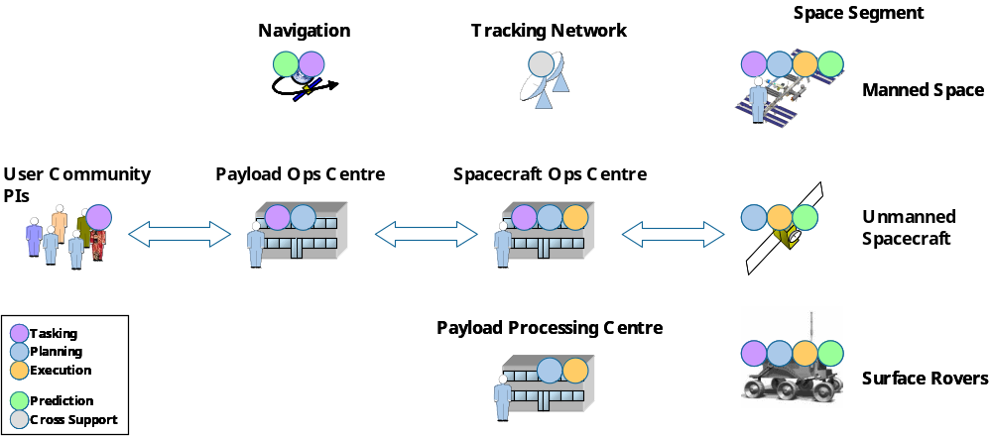
Figure 6. Entities and Functions Involved in Mission Planning.
Functions can distributed over various organizations and systems that together form a space mission system. The arrows indicate the interactions in a typical current deployment, but the potential distribution of functions indicated by the circles shows that all the functional interfaces shown in Fig. 5 can be exposed to the boundaries between these entities and are therefore candidates for standardization as MO Services.
Figure 6 illustrates potential deployment of each of the functions shown in Fig. 5 to the entities listed above. It is where the interactions between the functions are exposed across one or more boundaries between these entities that there is justification for standardization within CCSDS as a potentially interoperable interface between agencies. From this it is evident that all the interactions shown above are potential candidates for MO Services.

Potential Services and Exclusions
Prior to the discussion, the working group had identified two candidate MO Mission Planning services, corresponding to the interactions shown in Fig. 5 between Tasking and Planning, and between Planning and Execution:
- Tasking / Planning Request Service
- Plan / Schedule Distribution Service (including execution feedback)
These correspond to operational interfaces used routinely to support mission operations. The feedback received from the planning community is that they are seen as candidates for service standardization and that there would be a clear benefit to service level standardization that also addresses the interaction protocol rather than just limiting standardization to a data exchange format. Several participants expressed the opinion that standardization of the Scheduling service would be easier than standardization of the Planning Request service, because of the diversity in the content of tasking requests between missions. It was also proposed that a simple approach should be adopted initially for Planning Requests: standardizing the interaction between the user community and Mission Planning system, rather than the full content of the tasking requests themselves. This can then be refined as greater commonality between requests is identified.
In addition to these dynamic information exchanges, several participants identified a need to standardize the exchange of static planning configuration data. This is used by the Mission Planning function itself as part of the planning process and typically comprises planning constraints, rules and resource usage profiles. While this may be considered “private” to the Mission Planning function, in practice the nature of the planning constraints often needs to be understood by several actors in the system, including:
- Spacecraft and Payload Manufacturers
- PIs and Users
- Distributed Mission Planning systems (e.g. Payload and Spacecraft Operations Centres).
A general concern expressed is that the nature of this information may be specific to the Mission Planning algorithms and tools used. Standardization may therefore be difficult to achieve, and the interactions supported are both infrequent and off-line. The consensus was that this area should not be considered initially for standardization, but that emphasis should be given to the operational interfaces identified above.
Standardization of the provision of predicted orbital events is considered to be a candidate for MO Navigation services, rather than specifically associated with Mission Planning, but it was suggested that the mission planning community should also be involved in the standardization process.
It is accepted that the process by which space link service providers and space missions exchange information needed to arrange spacecraft contact periods is excluded from the scope of MO Services as it is already addressed by the CCSDS Communications Cross Support Service Management Standard⁵.

MO Service Definition
Specification of application level MO Services requires:
- Definition of the associated Information Model (Service Objects)
- Definition of the Service Operations, each mapped to a MAL interaction pattern
- Provision of Service Configuration (Object Definitions) for service deployment
The following does not require specification as it is provided by the MO Service framework:
- Message Encoding/Binding to the Messaging Technology (providing the required binding is already available)
- Specific Definition of the API – standard language transformations apply to all MO Services for supported languages and can be used to autogenerate the API.
- Definition of Service Discovery, Login, Authentication, etc. as these are covered by the MO Common Services Specification
- Specification of a dedicated Service History Model as this can be derived from the MO COM
A key aspect of service definition will be to define the information model associated with these interfaces. The first challenge in standardisation will be to agree common terminology that can be used to describe the service information model and operations.
Representation of plans or schedules is not limited to simple time-tagged lists of commands, but increasingly will need to represent operations tagged by other initiation criteria, including position, predicted events, state conditions or user interventions. Other aspects may need to be reflected in the model, such as applicable configuration, allocation of operational responsibility and priority. Similarly, the information model for planning requests may need to address discrete, serial and repetitive operations.
In addition to information structures, service definitions also address the pattern of information exchange that is required between collaborating systems or components. This includes the dynamic update of service data, for example to provide feedback on execution status of schedules, or to reflect changes to a plan or schedule made by a collaborating system. Service operations can be defined to support:
- Injection of Planning Requests – either individually or as a batch
- Provision of feedback on the status of a Planning Request
- Publishing of a new or updated Plan or Schedule
- Modification of the Plan/Schedule – either discrete changes or in batch
- Provision of feedback on the status of the Plan/Schedule – either live or as a batch off-line update, and for both planning changes and execution status.

Existing Standards and other Inputs to Standardization
Before development of any MO Mission Planning Services takes place a full survey of existing standards and other potential inputs to the standardization process will need to be performed to ensure that there is no unnecessary duplication of standards and that full advantage is taken of any existing body of work. A number of potential sources were identified by participants in the workshop. These include:
- The OGC OpenGIS Sensor Planning Service⁶
- The European Ground Segment Technology Harmonisation Programme
- Planning Domain Definition Language (PDDL)⁷
PDDL has been under development in the planning academic community for some years and offers a potential solution for the exchange of planning configuration data.

Case Study: Venus Express
This section contains a specific case study of ESA’s Venus Express mission. This note summarises all the Mission Planning related interfaces in the Venus Express system and highlights aspects that could be generalised with a view to standardisation in the scope of CCSDS MO Mission Planning Services.
It is noted that preliminary conclusions are based on review of a single system and are therefore subject to discussion and revision when considering wider standardization of Mission Planning services.

Overview
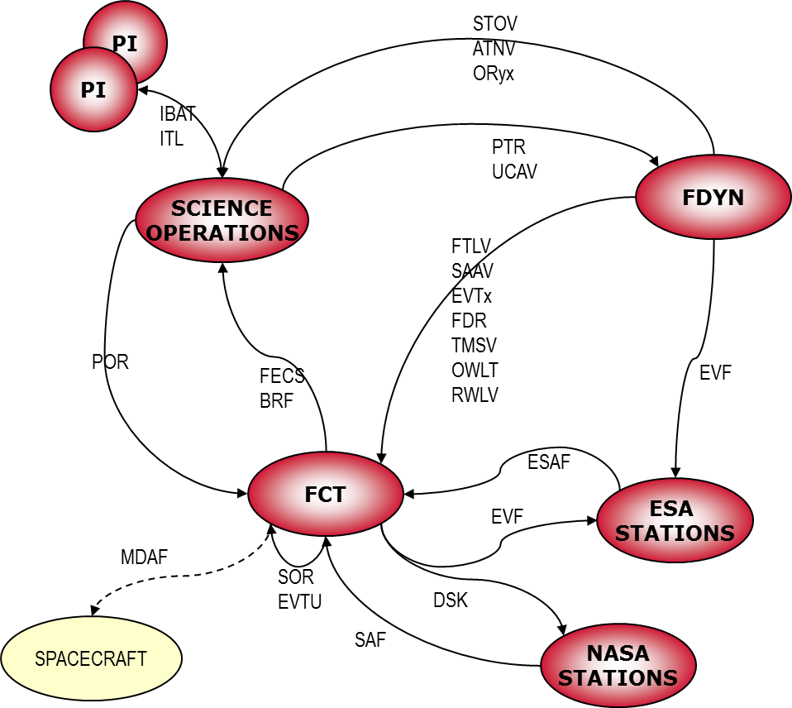
Figure 7. Some of the different products (consisting of Timelines of data) exchanged between planning parties in VEX
Venus Express is an example of a Mission with streamlined interfaces, nevertheless it counts:
- 48 different types of products being generated by all parties, grouped in 43 single interface types – further grouped in 28 functional interfaces – this accounts for all the forms of data that are required to be exchanged and is not here subject of contestation.
- Using 36 different containers for this data (most are file based, and correspond to as many file formats) – here there is certainly room for improvement, because this translates in expensive costs in parsers and coders across the whole ground segment.
- Using at least 5 different mechanisms of transportation (FTS, FTP, HTTP, Email, soon also FIDES) – this needs some harmonisation but is mostly related to data package size issues and availability as well as deployment of applications on different platforms and crossing of fire-walls or exposure to external world.
- More importantly the exchange mechanisms (even if described in documentation) are in most cases rather ad-hoc, requiring manual intervention from the users at one level or another (manual triggering of transmission, scanning emails for relevant info, moving files across machines and directories, manual archiving, visual file checking, manually and informally typed notifications, attaching configuration data in emails, etc.).
When the full set of interfaces is considered, it is apparent that there is room for consolidation and standardisation of some aspects of these information exchanges.

Preliminary Conclusions on Standardisation Scope
This section presents preliminary conclusions on the scope of standardized MO Mission Planning services and where the responsibility for standardization should be assigned.

What Not to Standardise
Standardisation of the contents should not be attempted in the scope of the SM&C group. This requires the support of specific experts and is a job for communities that share a specific interest in that data. For example:
- Navigation working group for Orbital Events
- Station Scheduling group for Track Events
- Mission Planning group for exchange of Timelines and other classes of Schedule
Other contents are in many cases, strictly mission specific. Any standardisation attempts must ensure that standards are genuinely generic and applicable to multiple missions and mission classes.
Standardisation of Mission Planning setup and intervening parties should also not be attempted. The possibilities and combinations are too numerous to make any reasonable sense.
Standardisation of Planning Functions (e.g. Station booking, orbit determination, command generation, etc. ) should not be initially attempted. Even though some functions are similarly called the actual possibilities and nuances are so many and varied that makes the task rather complex and risky. In a later phase, it may be possible to identify 10 or 20 common functions, and leave room for missions to add private functions. Initially it may be advisable for all functions be private. In any case it is noted, that MO Services do not standardize the functions themselves, only the exposed interfaces of those functions.

What to Standardise
Something that could be standardised initially, at a low cost and risk, and with a view to support any function, are container structures (or wrappers) for the different types of data identified, in combination with different exchange mechanisms. And these combinations could be called Generic Planning Services (as opposed to Functional Services in the case the functions were also fixed).

By systematically analysing all the interfaces in this example mission we conclude that, in terms of type of data exchanged, and independently of the actual content and meaning of the data, they all fall under one of the following 3 categories:
- Timelines
  - Contains items that are assigned to specific times within a given time range (period)
  - The times may be in any time reference frame: absolute time, event-based, location-based, etc.
  - Can contain one or more Requests for performing (scheduling, modifying or removing) activities.
    - The requested activities are under control/responsibility of the destination party
    - Requests can be instantaneous, with a finite duration or may follow each other continuously in time (as in requesting modes)
    - Requests may have additional attributes to qualify them (parameters)
  - Can contain one or more Occurrences (including events, modes, planned activities, etc.)
    - The Occurrences are known, scheduled or predicted by the source party (a view of a sub-set of plan data).
    - Occurrences can be instantaneous, with a finite duration or may follow each other continuously in time (as in representing modes)
    - Occurrences may have additional attributes to qualify them (parameters)
  - Can contain one or more discrete Data Series representing the evolution over time of any given quantifiable parameter.
    - Values can be sampled at regular intervals or only when they change
    - There may be several different parameters sampled at the same instant
  - A standard structured container for this type of data, including the 3 generic sub-types could be standardised.
- Notification
  - Contains items that have no time information
  - Are produced asynchronously as a reaction or response to any particular occurrence (e.g. to indicate reception or availability of data or other resources, etc.) or synchronously (e.g. to indicate the availability of a process)
  - May contain additional appended data
  - A standard container for this type of data could be standardised with possibility to append any kind of data.
- Configuration Data
  - Can contain Database
    - Databases are structured and relational sets of data from the knowledge base of a given party (metadata)
    - They expose to other parties what they can request from the source (e.g. activities and how they breakdown to smaller entities and their associated parameters and calibrations)
  - Can contain Parameters
    - These are simpler sets of static data without any relational information
    - They expose to other parties lists of relevant quantities or information associated with any given process or activity (e.g. constant definition, memory dumps or images, lists of resources, lists of addresses, lists of machines or accounts, etc.)
  - Can contain Rules/Goals/Constraints
    - They expose to other parties the preferences or guidelines for obtaining systematically requests over time, that satisfy the source party needs, without having to be specific about those times.
    - These have to be expressed in an appropriate language
    - They can be executed by an automatic process if the language is formalized.
    - They are typically needed when there are multiple parties accessing the same resource and an optimal allocation is required (in particular if AI methods are involved), or when the process of obtaining a given resource is very systematic and regular, in which case a rule simplifies the amount of data needed to be exchanged in the interface.
  - Can contain Models
    - These are representations of system behaviours used to emulate its response to operations, or representations of any given environmental phenomena that affects operations in any way, or representations of a particular planning domain that constraints operations (in particular for AI methodologies).
    - They have to be expressed in an appropriate language
    - They can be propagated by an automatic process (if the language is formalized)
    - They expose the mechanisms behind state changes of a given system, or the algorithms and formulas that describe the evolution of the system or phenomena over time in terms of its quantifiable properties, or describe the boundaries of a given planning domain.
    - They can be as simple or as complex as required depending on the accuracy desired for the results
    - They are very specific to particular missions and specific planning problems within that mission, although there are potential for generalisation in some cases (e.g. power generation model, gravity model, atmospheric models, etc.).
  - Standard containers for these types of data are complex to standardise, because the data structures and possible languages used may be very complex and vary significantly from mission to mission, nevertheless a wrapper for containing this type data could be standardised to facilitate transfer and map it to the interaction mechanisms.
In terms of how the data is actually exchanged (independent of the transport medium) we have identified that the majority of current transactions in the VEX system are unidirectional and on availability of the data in question. This may, however, be more a consequence of current technical limitations than deliberate choices. So one can assume that at least the following forms of interaction are common and required for exchanging (automatically) planning data in any mission (I don’t exclude that there may be more):
- Send (Push) or Broadcast
  - Initiated by the source (data provider)
  - To a single destination (Send) or to multiple (Broadcast)
  - Typically triggered by availability of data after a given process has taken place
  - May required destinations to subscribe in advance to obtain the data
  - May be at regular time intervals or asynchronous
  - Destination must be prepared to receive and interpret the data (shared configuration)
- Send and Get Feedback(s)
  - Initiated by the source
  - To a single destination
  - May be at regular time intervals or asynchronous
  - Multiple Feedbacks may be expected from the same source
  - Feedback may be immediate or delayed (until some process is complete)
  - Feedback is of type notification
  - Destination must be prepared to receive and interpret the data and source must be prepared to receive and interpret the feedback (shared configuration)
- Subscribe
  - Initiated by the destination (data receiver)
  - To a single or multiple data sources
  - By nature it is performed asynchronously as new data sources become available
  - Involves typically exchange of addresses for data, security protocol parameters and possibly any other configuration data
  - Will cause the subscribed data to be routed to the destination when available
- Get (Pull)
  - Initiated by the destination (data receiver)
  - To a single or multiple data sources (or repositories)
  - Destination must have shared knowledge about the data properties available at the source (shared configuration)
  - May be at regular time intervals or asynchronous
- Report
  - Initiated by any party
  - To a single or multiple parties
  - May be at regular time intervals (e.g. a keep alive signal) or asynchronous (e.g. anomaly detection)
Although these are not expressed directly in terms of the MAL interaction patterns, initial analysis would indicate that these can all be mapped to those patterns and hence defined as operations of an MO Mission Planning service
Another area to focus is terminology as mentioned in the CCSDS workshop. Words like: Request, Timeline, Planning Plan, Scheduling, Schedule, Event, Occurrence, Task, Activity, Operation, Fact, Command, Mode, Rule, Goal, Constraint, Target Window, Pass, etc. need to be unambiguously defined and structured (hierarchically) such that it is clear for all parties what is meant. Currently there are many flavours and nuances of these terms used in the context of Planning.

Proposal for Generic Planning Services
Given the 3 categories of data types and the 5 categories of data interaction identified, the following generic Planning Services could be standardized:
- Timeline (or Schedule)
- Notification
- Configuration
Each comprising operations corresponding to the identified categories of data interaction.
For configuration data one wrapper has been proposed to support data exchange, but any standardisation efforts could look into available sub-types of configuration data and recommend best practices or commonly used languages. Within ESA, work has been done on harmonisation of configuration databases for ground segment (e.g. ESA-DARC), some work done on rule languages and engines (e.g. ESA-LMP), standards to support system modelling (SMP2), languages for problem domain description and goal/constraint descriptions (ESA-Advanced Planning Initiatives, etc.).
One first step to confirm the premises postulated in this case study, is to attempt to have other missions (of different types and agencies) map their interfaces to these categories (of data and interaction – without considering content and transport) and analyse critically the cases where a match could not be found to determine if a real independent category is missing or not. Missing categories could be then proposed and discussed, keeping in mind that the standard should remain as simple and generic as possible.

Once a final set is consolidated, it would be possible to map any interface content, from any planning function to an appropriate Generic Planning Service, such that any two parties agreeing to share planning data would have for granted the container and the interaction mechanism, and would only need to agree on specific content and its parameterisation and low level transportation means. The interaction mechanisms could be automated by defining an API.

Conclusions
Development of standard Mission Planning Services based on the MO Service framework developed by the CCSDS Spacecraft Monitoring & Control working group would promote software re-use and simplify the integration of distributed mission planning and wider mission operations systems. A call for interest in the topic resulted in significant support at a workshop held during the CCSDS technical meeting held in Darmstadt, Germany in April 2012. This did not result in universal agreement on the scope of potential MO Mission Planning services, but recommended an initial focus on operational interfaces including Planning Request and Scheduling services, rather than attempting to address the more complex problem of exchanging planning constraints and other configuration data. An important aspect of service standardization for the operational planning interfaces is to address the interaction protocols used to exchange information as well as the information content of those interactions. This is expected to deliver operational benefits in the short-term as it avoids manually intensive exchanges via ad-hoc mechanisms including telephone and e-mail. For the information content itself it is recommended that this is initially kept simple, but extensible to allow incremental development of the standards to support different mission classes and deployment scenarios. The first step in standardization of MO Mission Planning services will be harmonization of the terminology to be used in the specification of standards, to ensure a common understanding between different organizations.
The Mission Planning workshop will be repeated at the next CCSDS Technical Meeting in Cleveland, Ohio in the fall of 2012. If sufficient support can be obtained from multiple space agencies, then the process of establishing a new CCSDS working group to develop the standards will be initiated.

